**Adama science and Technology University**

SCHOOL OF ELECTRICAL ENGINEERING AND COMPUTING

Department of computer science and engineering

**Course Title:** Fundamentals of Software Engineering

**Course code:** CSE3205

**Project Title:** Blood Bank management System for Addis Ababa (web based)

**Section 1**

**Fundamental of software Engineering Project**

**Acknowledgement**

We would like to extend our sincere thanks to all who participated in developing and creating this software documentation. We are highly indebted to Adama Science and Technology University for the opportunity it gives us to work on this project and explore further knowledge.

We would like to express our deepest gratitude towards our advisor Mr.Mengistu for his guidance and constant supervision as well as his kind co-operation and encouragement, which helped us in completion of this project.

**Acronym**

BBMS……………………Blood Bank Management System

HTML……………………. Hypertext Markup Language

CSS………………………. Cascading style sheet

JS…………………………Java script

SQL………………………. Structured Query Language

MS word………………….. Microsoft word

Table of Contents  
Acknowledgment ……………………………………………………………………………………………………………….. ii  
Acronym …………………………………………………………………………………………………………………………….iii  
Table of Contents ………………………………………………………………………………………………………………….v  
List of figures …………………………………………………………………………………………………………………….viii

List of Table ………………………………………………………………………………………………………………………viii

1. **Chapter one** 
   1. Introduction …………………………………………………………………………………………………………………1
   2. Background of the organization [optional] ……………………………………………………………………..1
      1. Mission of the organization ……………………………………………………………….......................1
      2. Vision of the organization……………………………………………………………………....................1
   3. Background of the project………….……………………………………………………………................................2
   4. Statement of the problem ………………………………………………………………………….............................2
   5. Justification of the project…….…………………………………………………………………................................3
   6. Objective of the project ……………………………………………………………………………..............................3
      1. General objective ………….………………………………………………………………….......................3
      2. Specific objective ………….………………………………………………………………….......................3
   7. Scope and limitation ………………………………………………………………………………...............................3
      1. Scope of the study ……………………………………………………………………………......................3
      2. Limitation of the project …………………………………………..………………………......................4
   8. Feasibility study ……………………………………………………………………………………................................4
      1. Technical feasibility.………………………………………………………………………….....................4
      2. Operational feasibility.………………………………………………………………………....................5
      3. Economic feasibility ……………………..……………………………………………………..................5
   9. Significance of the project …………………………………………………………………………..........................6
   10. Beneficiaries of the project …..…………………………………………………………………...........................6
   11. Methodology …………………………………………………………………………………………...........................6
   12. Development tools …………………………………………………………………………………..........................7
   13. Required resources with cost ……………….………………………………………………….........................7
   14. Task and Schedule ….……………………………………………………………………………….........................7
   15. Team composition …………………………….…………………………………………………………………...…8

**Chapter 2**

1. Description of existing system/ Literature Review ……………………………………………..........................9
   1. Major function of existing system ……………………………………………………………….........................9
   2. Users of current system …………………………………………………………………………….........................10
   3. Drawback of current system ……….…………………………………………………………….........................11
   4. Business rule ……………………………………………………………………………………………........................11

**Chapter 3**

1. Proposed System …………………………….………………………………………………………………........................13
   1. Overview …………………………….…………………………………………………………………….......................13
   2. Functional requirement ……………………………………………………………………………........................13
   3. Non-functional requirement ………………………………………………………………………......................14
   4. System model ……………………………………………………………………………………………......................15
      1. Scenario ………………………………………….………………………………………………………15
      2. Use case model ……………………………..…………………………………………………………25
   5. Object model ……………………………………………….……………………………………………………….42
      1. Data dictionary ………………………………….…………………………………………………….42
      2. Class diagram …………………………………………………………………………………………42
      3. Dynamic model ………………………………………………..……………………………………...46
      4. Sequence diagram …………………………………………………………………………………...46
      5. Activity diagram ………………………………………………………………………………………59
      6. State chart diagram ………………………………………………………………..………………..71

**Chapter 4**

1. System design………………………………………………………………………………………………………………85
   1. Overview of system design ……………………………………………………………………………………85
      1. Purpose of the system design ……………………………………………………………..…….85
      2. Design goal ………………………………………………………………………………………………85
   2. Proposed system architecture ……………………………………………………………………………….87
      1. System process ………………………….…………………………………………………………….88
      2. Subsystem decomposition ………………………………………………………………………..91
      3. Hardware/ software mapping …………………………………………………………………..93
      4. Persistent data management …………………………………………………………………….94
      5. Component diagram …………………………………………………………….…………………..99
      6. Deployment diagram………………………………………………………………………………..100
      7. Database design ……………………………………………………………………………………….101
      8. Access control ………………………………………………………………………………………….102
      9. User interface design ………………………………………………………………………………..103

**List Of Figures**

Figure 1. Use case Diagram...........................................................................................................27

Figure 2. Class Diagram.... ...........................................................................................................45

Figure 3. Sequence diagram for Donor view personal information..... .......................................46

Figure 4. Sequence diagram for Donor register. ..... .....................................................................47

Figure 5. Sequence diagram for Request Blood. ...... ...................................................................48

Figure 6. Sequence diagram for Register donor..... ......................................................................48

Figure 7. Sequence diagram for update donor....... .......................................................................49

Figure 8. Sequence diagram for View Personal Information.... ..................................................50

Figure 9. Sequence diagram for View donor Information..... .......................................................51

Figure 10. Sequence diagram for send report.... ...........................................................................52

Figure 11. Sequence diagram for View Received Report...... ......................................................53

Figure 12. Sequence diagram for Check Blood In Store...... ......................................................54

Figure 13. Sequence diagram for Request Blood...... ................................................................55

Figure 14. Sequence diagram for Register Camp..... .................................................................56

Figure 15.Sequence diagram for Register Hospital..... .................................................................57

Figure 16. Sequence diagram for Update Camp...... .................................................................58

Figure 17. Activity diagram for add donor..... ..............................................................................60

Figure 18. Activity diagram for Request Blood...... .....................................................................61

Figure 19. Activity diagram for Register hospital..... ..................................................................62

Figure 20. Activity diagram for update hospital..... .....................................................................63

Figure 21. Activity diagram for sending warning message to hospital and camp........................64

Figure 22. Activity diagram for request blood..... .........................................................................65

Figure 23. Activity diagram for register camp..... ........................................................................66

Figure 24. Activity diagram for view blood in stock.... ................................................................67

Figure 25. Activity diagram for view report..... ............................................................................68

Figure 26. Activity diagram for update donor..... .........................................................................69

Figure 27. Activity diagram for user login...... .............................................................................70

Figure 28. state chart diagram for user login...... ........................................................................72

Figure 29. State chart diagram for Add donor..... .......................................................................73

Figure 30. State chart diagram for update donor........ ................................................................74

Figure 31. State chart diagram for register hospital....... .............................................................75

Figure 32. State chart diagram for send report....... .....................................................................76

Figure 33. State chart diagram for request blood...... ..................................................................77

Figure 34. State chart diagram for register camp...... ..................................................................78

Figure 35. State chart diagram for view personal information.... ................................................79

Figure 36. State chart diagram for update hospital. ..... ................................................................80

Figure 37. State chart diagram for update camp. ..... .................................................................81

Figure 38. State chart diagram for view received report. .... ......................................................82

Figure 39. State chart diagram for view donor information.... .....................................................83

Figure 40. State chart diagram for view blood in stock...... ..........................................................84

Figure 41. Proposed System Architecture...... ..............................................................................87

Figure 42. System Activity Diagram..... .......................................................................................88

Figure 43. System process diagram for camp..... ..........................................................................88

Figure 44. System process diagram for Admin.... ........................................................................89

Figure 45. System process diagram for Hospital.... .....................................................................89

Figure 46. System process diagram for donor..... .........................................................................90

Figure 47. System Subsystem Decomposition....... ......................................................................91

Figure 48. Hardware/software mapping....... ................................................................................93

Figure 49. Persistent data management.......................................................................................98

Figure 50. Component diagram.......... ........................................................................................99

Figure 51. Deployment diagram...... ...........................................................................................100

Figure 52. Database design............. ............................................................................................101

Figure 53. User interface design......... .......................................................................................10

List of Tables

Table 1. Frontend implementation software tools..........................................................................7

Table 2. Backend implementation software tools...... ....................................................................7

Table 3. Task and schedule.... ........................................................................................................8

Table 4. Team Composition...... .....................................................................................................8

Table 5. Use case description for Add donor. ...............................................................................28

Table 6. Use case description for login..... ....................................................................................29

Table 7. Use case description for update donor..... .......................................................................30

Table 8. Use case description for view personal information..... ..................................................30

Table 9. Use case description for view donor information.... ......................................................31

Table 10. Use case description for send report.............. ...............................................................32

Table 11. Use case description for view received report..... .........................................................33

Table 12. Use case description for check blood in store..... ..........................................................33

Table 13. Use case description for request blood......... ................................................................35

Table 14. Use case description for register camp....... ..................................................................36

Table 15. Use case description for register hospital...... ...............................................................37

Table 16. Use case description for update hospital...... .................................................................37

Table 17. Use case description for update camp............ ...............................................................38

Table 18. Use case description for view status of stock........ .......................................................39

Table 19. Use case description for send warning signal to hospital and camp..............................40

Table 20. Use case description for send warning signal to view bloods in stock..........................41

Table 21. Use case description for view received request.............................................................41

Table 22. Use case description for deliver blood to hospital.........................................................42

Table 23. Data dictionary...............................................................................................................45

Table 23. Subsystem Decomposition Description.........................................................................95

Table 24. Access control.............................................................................................................106

**Chapter One**

* 1. **Introduction**

A blood bank is a center where blood gathered as a result of blood donation is stored and preserved for later use in blood transfusion. The term "blood bank" typically refers to a division of a hospital where the storage of blood product occurs and where proper testing is performed (to reduce the risk of transfusion related adverse events). However, it sometimes refers to a collection center, and some hospitals also perform collection. Blood banking includes tasks related to blood collection, processing, distribution and storage.

Blood donation is required during an organ transplant, accidents, cancer treatment etc. For blood donation, one needs to check for a donation camp or needs to visit blood bank. The Manual Blood donation system has many disadvantages which includes, it is too time consuming, often leads to error prone results, consumes lot of manpower, lacks donor information, retrieval of data takes a lot of time, percentage of accuracy is less. In the time of emergency, it becomes difficult to approach the right donor. Rare blood groups are not available all the time at all blood banks and recipients find difficulties to track the right blood donor. To overcome this problem, distributed blood bank management project has proposed a system. There are many blood donation management systems, but these systems only maintain the information of blood banks and donors. But distributed blood bank management projects has proposed a system which not only maintains the information of blood banks, but also maintains information of blood camps which makes blood transfusion process easier. This blood management system maintains the list

of blood donors and also helps the recipients to track and search the right donor easily.

This project aims at maintaining all information regarding blood donors, different blood groups available in blood banks as wells as blood camps and help them manage in a better way.

* 1. **Background of the organization**

***1.2.1****)* ***Mission of the organization***

The mission of the Ethiopian national blood service is to provide all patients with sufficient safe, quality blood product and medical services related to blood transfusion in an equitable, cost effective manner.

***1.2.2) Vision of the organization***

To be the cornerstone of the healthcare services in Ethiopia on gift of life.

* 1. **Background of the project**

National Blood Bank Services Office is the nonprofit governmental organization established with core function of community mobilization & education on voluntary blood donation, blood collection, laboratory processing, testing & production of blood, distribute to health facilities, Promote appropriate clinical use of blood, research & capacity building in BTS.

The National Blood Transfusion Services (NBTS) was established in 1979 by Ethiopian Red Cross society since 2004 it has been transferred to Federal Ministry of Health Ethiopia, and entrusted with the responsibility of managing the Blood donors, collection, testing and transfusion of blood and blood products in Ethiopia.

Currently, blood banks connect to the public or publicize information by using conventional media means such as radio, newspaper or television advertisements. The donor records are stored in MS access application of every blood bank independently and communicate with medical centers by using phone or by being present physically for requesting required blood and transaction.

The project is proposed to store, process, retrieve and analyze information concerned with the blood inventory management within a blood bank. This project aims at maintaining all the information gathered from blood donors, different blood groups available in each blood bank and help them manage in a better way and to provide transparency in this field, make the process of obtaining blood from a blood bank hassle free and corruption free and make the system of blood bank management efficient.

* 1. **Statement of the problem**

Currently, the public can only know about the blood donation drives through conventional media means such as radio, newspaper or television advertisements. Even if there is an electronic means, it is only used to publicize about that hospital or medical center blood donation drives provided if that hospital or medical center is having an online portal. Besides, for those who want to make blood donation, they cannot make early reservation or booking on the session and day that they are available to donate blood. It is a very important facility for those who are very busy and yet enthusiastic people to know and be sure when they can make blood donation rather than trying to figure out where and when they can make blood donation when they available for donation.

There is no nationwide information regarding the blood donation drive available on any of the portal. With blood drive system it will make it easier to monitor and manage the blood drive operations. The system in place for blood donation has a number of limitations, first the blood donation is limited to a specific center that has been organized and planned for the blood drive and this leaves out a bigger population willing to donate blood but cannot access the center. Also the system in place conducts blood drives plainly in that they do not have prior information about the various blood types they are going to collect; this is a challenge because they may be looking for particular rare blood types if they do not have leads to where they will get those particular types of blood. Without an automated management system, there are also problems in keeping track of donor details. In addition, there is also no alert available when blood quantity is below its level. This is where the blood drive system comes in place; customers can get all blood donation information in this system instead of going and searching around for it.

* 1. **Justification of the project**

Ethiopian blood donation process have a lot of problems dealing with too much personal information so to make the data flows In that organization much easier we could implement these system to it.

The camp hospital and blood bank itself can work together easily using these system. We could also implement these system to make the work easy for those employees working in the organization.

* 1. **Objectives of the project**

***1.6.1) General objectives***

The general objective of the project is to design and develop distributed blood bank system for

Addis abeba city.

***1.6.2) Specific objectives***

In order to achieve the general objective the following specific objectives will be achieved.

* To design and develop web based interface for user to interact with the system.
* To design and develop a distributed database to store different data.
* To design communication mechanism between health facility and blood bank
  1. **Scope and limitation**

*1.7.1) Scope of the study*

The project will be executed in Blood banks, hospitals and organizations that organize for blood donation events and it aims at implementing and creating a platform that will help in blood donation and holding successful blood. Blood bank management system will enable the citizens who are well-wishers to contribute towards saving others life by donating blood.

The scope of the project includes the following activities.

* + Generate reports of the workflow for each blood donation process and status of every blood found in stock.
  + Record medical centers, donors, blood and other information to distributed database.
  + Enable users to update their own information.
  + Enable the users receive notification message when there is shortage of blood.
  + Enable the user to search information for quick access.
  + Publicize nationwide information about blood donation on the website.
  + Provide management mechanism of user information, blood information and resource

*1.7.2) Limitation of the project*

* New donors will have to go a hospital to examine their blood type.
* Not everybody will be able to use the system especially the computer illiterate people.
  1. **Feasibility study**

Feasibility is conducted to identify the best system that meets all requirements. It is both necessary and important to evaluate the feasibility of a project at the earliest possible time. Feasibility study includes an identification description, an evaluation of proposed system and feasibility study of the proposed system is to be carried out. This is to ensure that the proposed system is not a burden to shop. The feasibility study should be relatively cheap and quick. The results should inform the decision of whether to go ahead with a more detailed analysis for feasibility analysis, some understanding of the major requirements for the system is essential.

Three key consideration involved in the feasibility analysis are:

1. Economic feasibility

2. Technical feasibility

3. Operational feasibility

*1.8.1)* ***Technical feasibility***

The study is carried out to check the technical feasibility, that is, the technical requirements of the system. Any system developed must not have a high demand on the available technical resources. This will lead to high demands on the available technical resources. The developed system must have a modes requirement, as only minimal or null changes are required for implementing this system. This is related to the technicality of the project. This evaluation determines whether the technology needed for the proposed system is available or not. It deals with hardware as well as software requirements. That is, type of hardware, software and the methods required for running the system are analyzed. A study of function, performance and constraints may improve the ability to create an acceptable system, technical feasibility is frequently the most difficult area to achieve at the stage of product engineering process. The scope was whether the work for the project is done with the current equipment and the existing system technology has to be examined in the feasibility study. The result was found to be true. This feasibility is carried out to check the technical requirements of the system.

This system is implemented by using PHP. So it can be used in any windows OS computer. This system requires very low system resources and it will work in almost all configurations. In the existing system all functions are doing manually. So if they get this designed software, the problems can be avoided and thus the system will run smoothly. In the proposed system, data can be easily stored and managed using database management system software. The reports and results for various queries can be generated easily. Our proposed system is technically feasible to use by any user.

***1.8.2) Operational feasibility***

The purpose of the operational feasibility is to determine whether the new system will be used if it is developed and implemented and whether there will be resistance from user that will undermine the possible application benefits. The aspect of study is to check the level of acceptance of the system by the user. This includes the process of training the user to use the system efficiently. The user must not feel threatened by the system, instead must accept it as a necessity. The level of acceptance by the user solely depends on the methods that are employed to educate the user about the system and to make him familiar with it. His level of confidence must be raised so that he is also able to make some constructive. The proposed system is an upgrade version of the current system new fields have been implemented according to the user need, hence it ensure a user friendly environment in such a way that it ensures all the aspects. The proposed system is very much user friendly and the system is easily understood by simple training and it is operationally feasible to use by any users.

***1.8.3) Economic feasibility***

Economic feasibility is the most frequently used method for evaluating the effectiveness of the candidate system. It is very essential because the main goal of the proposed system is to have economically better result along with increased efficiency. A cost evaluation is weighed against the ultimate income or product. Economic justification is generally the bottom-line consideration that includes cost benefit analysis, long term corporate income strategies, and cost of resources needed for development and potential market growth. When compared to the advantage obtained from implemented the system its cost is affordable. Thus the developed system as well within the budget and this was achieved because most of the technologies used are freely available.

Installation of new system will reduce administrative and operational cost. The newly developed software that doesn’t require any existing manual paper works and files. So cost also can reduced by removing these types of materials. Proposed system was developed with available resources. Since cost input for the software is almost nil the output of the software is always a profit. Hence software is economically feasible.

* 1. **Significance of the project**

This project is necessary because it seeks to create a platform that will allow people to contribute towards saving lives of those people who need blood, with blood bank management system it is easier and faster to trace matching blood samples by simply checking the records of donors on the system, it also helps in reducing death rates in that the system also contains donor's details and contact information so that those in need of blood don't take much time in searching for blood donors whom they have less or no information about them.

The system will be also very effective in times of emergencies as it saves time and efforts for searching blood donors.

* 1. **Beneficiaries of the project**

Beneficiaries of this system includes

Blood bank staff workers:

* By reducing the effort in recording the donors info through replicated paper based system.

Hospitals:

* The hospitals makes blood requests easily during emergencies and where there is no enough blood in their stock.

Donor:

* The donor can see their donation info easily in transparent way.
  1. **Methodology**

The Incremental models is chosen in developing this project. This model has been selected because project can be developed through cycle of phase. The development of the project is that it must follow the phase that is a phase at a time. If there is any correction, it can be done in the middle of the process. Incremental model included five phases which are requirement analysis, design, implementation and unit testing, integration and system testing and operation.

***1.11.1) Data Source***

The core and the main valuable data source of our system is Ethiopia blood bank which located in Addis Ababa. therefore the main data source is Ethiopia Blood Bank.

***1.11.2Methodology Justification***

The incremental model is chosen to develop this project because of these some factor

*I. Security*

The model is more organized and easy to understand the flow

*II. Flexibility Allow*

To have changes happen in the middle of the process, the system still can be implemented and proceed so that all the modules that want to be achieved is success.

*III. Saves time*

As the system that is developed using the cyclic model, the developing of the project can be continuously done although there is some error in the middle of the process

* 1. **Development Tool**

This are tools that will help us to develop the application and to document the system facts.

|  |  |  |
| --- | --- | --- |
| **Tools** | **abbreviation** | **Use** |
| Hypertext markup language | Html4/html5 | For configuration |
| Cascading style sheet | CSS/CSS3 | For layout design ,content decoration in user interface design and to give the style of the interface |
| Java script/JQUERY | JS | For validating client side monitoring language |

Table 1.Frontend implementation software tools

|  |  |  |
| --- | --- | --- |
| **Tools** | **Abbreviation and version** | **Used for** |
| Hypertext preprocessor | PHP 5.6 | Backend implementation of the project. |
| MySQL Server | MySQL 5.6 | For database |
| WAMP,XAMPP server | To run the project |  |

Table 2. Backend implementation software tools

**1.13 Required resources with cost**

**1.14 Task and schedule**

|  |  |  |  |  |  |
| --- | --- | --- | --- | --- | --- |
| **Phases** | **Months** |  |  |  |  |
| Nov 20  -  Dec 2 | Dec 2  -  Dec 15 | Dec15  -  Jan 4 | Jan4  -  Jan 12 | Jan 12  -  Jan 20 |
| Requirement gathering and Analysis |  |  |  |  |  |
| Design |  |  |  |  |  |
| Implementation |  |  |  |  |  |
| Testing |  |  |  |  |  |
| Maintenance |  |  |  |  |  |

## Table 3. Task and schedule

# **1.15) Team composition**

|  |  |  |  |  |  |  |  |  |
| --- | --- | --- | --- | --- | --- | --- | --- | --- |
| Title | | BLOOD BANK MANGEMENT SYSTEM FOR ADDIS ABABA | | | | | | |
| Team composition | | Name |  | | | Email | Roll | |
| Ugr/19598/12 | | | Fekede Alemayehu | [Fekedealemayehu4@gmail.com](mailto:Fekedealemayehu4@gmail.com) | Coordinating, Designing ,analysis, implementation and Programming | |
| Ugr/20563/12 | | | Dawit Nigus | [kingodawit@gmail.com](mailto:kingodawit@gmail.com) | Requirement Gathering, Designing, ,analysis, implementation and Testing | |
| Ugr/19834/12 | | | Derese Daniel | [deresednl@gmail.com](mailto:deresednl@gmail.com) | Programming, ,analysis, design, implementation and Testing | |
|  | Ugr/19673/12 | | | Dawde Seifu | | [seifudawde@gmail.com](mailto:seifudawde@gmail.com) | | Designing, Programming, ,analysis, implementation and Testing | |

Table 4. Team Composition

**Chapter 2**

**2**. **Description of Existing System**

There are two types of process in the existing system: the blood donation process by donors, and the blood request process by hospitals. In both processes, an administrator is in charge of managing the blood inventory in the blood bank.

When a new donor comes to donate blood, they are required to fill out their personal information during the registration process before making a donation. After the donation, the donor is given a donor identification card with their name, blood type and an id number to be used as a reference for future donations. Only blood bank administrators have the authority to access the donor’s records, since the system is only available for their use within the organization. This makes it difficult for donors to make changes to their personal information within the system. That is, for donors to update their personal information, such as their phone number, mailing address, or e-mail, they cannot update the information by themselves, but have to contact the blood bank center to update their information.

Hospitals can request for blood by calling in or e-mailing the blood bank the type of blood and the quantity that is in need. The administrator is responsible in checking the availability of the blood type according to the request. If the requested blood type is available, the administrator will withdraw the blood from the inventory and transfer it to the hospital. However, if the requested blood is unavailable, the administrator will send an e-mail to inform the hospital.

**2.1 Major Function of the Existing System**

Currently The System Is Running Manually. And It Mainly Includes the Following functions

1. The Donation
2. Testing
3. Storage
4. Distribution
5. Transfusion
6. **The Donation**

* You arrive for your blood donation appointment.
* Health history and mini physical are completed.
* For a whole blood donation, about 1 pint of blood is collected; several small test tubes of blood are also collected for testing.
* Your donation is kept on ice before being taken to a Red Cross center for processing; the test tubes go to the lab.

**2. Testing**

* A dozen tests are performed, to establish the blood type and test for infectious diseases.
* If a test result is positive, your donation will be discarded and you will be notified (our test results are confidential and are only shared with the donor, except as may be required by law)

**3. Storage**

* When test results are received, units suitable for transfusion are labeled and stored.
* Platelets are stored at room temperature in agitators for up to five days.

**4. Distribution**

* Blood is available to be shipped to hospitals 24 hours a day, 7 days a week.
* Hospitals typically keep some blood units on their shelves, but may call for more at any time, such as in case of large scale emergencies.

1. **Transfusion**

* An ill or injured patient arrives at a hospital or treatment center.
* Physicians determine whether the patient requires a transfusion and, if so, which type.
* [Blood transfusions](https://www.redcrossblood.org/donate-blood/blood-donation-process/what-happens-to-donated-blood/blood-transfusions.html) are given to patients in a wide range of circumstances, including serious injuries (such as in a car crash) surgeries, child birth, anemia, blood disorders, cancer treatments, and many others.  A patient suffering from an iron deficiency or anemia may receive red blood cells to increase their hemoglobin and iron levels, improving the amount of oxygen in the body.

**2.2 Users of the existing system**

Users are entities that interact with the system .It concerns only in Blood Bank management system. There are many basic beneficiaries which can get benefits from The DM blood bank Services which are

1. **Blood Donors**

person who wants to donate the blood voluntarily at the blood donation Camp.

1. **Hospital**

An Organization who wants the blood from the blood bank due to various reasons like accidents, surgeries, delivery and many more.

1. **Blood bank**

Staff people, who are working in the blood bank, which includes staff member, operator, blood bank in charge, head of pathological department.

1. **Nurses**

Check donor healthiness and received blood.

1. **Administrators**

Managing, supervising, budget all of action for the overall activity of the system

1. **Lab Technician**

Test blood, give blood for client hospitals and manage the sock.

1. **Data Encoder**

Register all the donor profile and send report for manager.

**2.3 Drawback of the current system**

* Currently, the system is totally manual.
* The manual system is slow then the computerized system.
* It is very time consuming.
* It is very complex system.
* It is required more clerical work and use more man power.
* The current system is not user friendly.
* It takes too much cost to perform procedure.
* It is difficult to store the data

**2.4 Business rules**

* The Blood Bank’s core functions include blood collection, blood grouping, infectious testing, component preparation, and blood components disposition. Currently, all the data and information exchange and processing of the functions of Blood bank is done manually. Only
* Access Database is used to keep records of donor’s, Recipient’s, and hospital’s information in the current system. Information is highly exposed to error, incompleteness, lose as well as damage. Generally, the following business rules (BR) are used in the project
* BR1

Donors must be at least 18 years old or at most 65 years old.

* BR2

If donor have desire to "give back", he/she can be donate his/her blood to the community in every 3 Months.

* BR3

No donation if the Donor have any disease and not in proper health condition.

* BR4

The blood in the bloodstock is expired after 35 days.

* BR5

If donor has a temperature above 37.5 C, donor may not donate.

* BR6

Persons who is pregnant is not eligible to donate wait 6 weeks after giving birth.

* BR7

Donors should not give blood if they have AIDS or have ever had a positive HIV test.

* BR8

If donor had hepatitis, donors are not eligible to donate blood.

* BR9

If weight of donor is between (45-50) kg can donate blood up to 350ml and if greater than 50kg can give 450ml at a time.

* Therefore, BR1, BR2, BR3, BR4, Are used in the proposed system the rest are used in existing system.

**Chapter 3**

**Proposed system**

**3.1 Overview**

The inspiration of this project is to improve blood bank management system in Ethiopia and to develop a blood bank information system which focuses on making an online system that is accessible for both donors and administrators. Donors can directly receive information regarding their previous blood donations, including their blood results and donation history, in order to easily schedule their next donations. The system is also developed for the administrators, who are the main authority in the system. Administrators can add, modify, delete, and query any donation information if necessary. The administrator is also responsible for responding to the hospital’s blood requests and checking the stocks in the blood bank’s inventory.

**3.2 Functional Requirement**

The system functions and features of our system will include the following:

1. **Registration**

This function allows:

* administrator register camps and hospital to give an access to make a donation event
* Administrators, camps and hospital register a donor when they are first comers as a user to interact with the system.

1. **View information online**

* The Administrators, camps and hospitals can view information about the donors by their unique ID.
* Donors are allowed to view their blood donation records and also check the availability of the blood in stock online by their given account.
* Anonymous user can check the availability of the blood in stock online

1. **Recording donation records**

* The system is able to record data of whole blood which is which is recorded at Camp, hospital and also the donated data at the Blood bank.
* The system also records donated number of donation.
* The donation records for different branches of blood bank(**optional)**.

1. **Manage blood inventory**

In our system the following managements are proceeded:

* Administrators manages donors, camps and hospitals info.
* Camps and hospitals manages donors info.

1. **Request blood**

The hospital can make request through the system by filling the form.

1. **Notification**

* The donor’s account and generated password will be sent via e-mail or phone.
* Hospitals can also receive e-mail responding to their requested blood whether it is available in our stock or not (**optional**).
* The Administrators receive notification while the hospitals make request.
* The Administrators receive notification while the hospitals and camps do the report.

1. **Summary report**

These are:

* Camps and hospitals are able to write a report to summarize all daily records including blood donation and received blood for the administrator.

1. **Warning Signal**

The blood bank sends a warning signal to the camps and hospitals if there is a deficiency of bloods in the stock in respective of their blood type.

**3.3 Non-functional requirement**

Non-functional requirements are requirement, which has no essential for the system, but it can support and give more quality for the system.

**A. Users interface requirement**

- User interface should be menu driven and attractive.

- The interface should be user friendly.

- The system should support error-handling mechanism that display graphic approach and the system guide the user what will be the next action.

**B. Authentication Requirement**

- The system support user name and password to authentic.

-The system has different privilege to protect intruding.

**C. Error handling requirement:**

The system has error handling mechanisms that is, as errors occur it will not stop functioning rather provide error manages and back to the previous page to give chance to reenter data and process the task by beyond the error.

**D. Well documented:**

The document of this project is processed in well manner

**E. Resources:**

The system is compatible with specified hardware and software environment

**F. Usability**

The system is user friendly. The new system provides web application user interfaces that are compatible with any browsers.

**G. Hardware consideration:**

The following sub-sections discuss the various aspect of hardware requirement.

-Computer

-Android running smart phone

-Server

**H. Software consideration:**

-Network connection

-Server connection

**I. Performance requirement**

The system performs its task within a user acceptable time and space. This includes the following:

-Response time: - depending on the strength of available network the system should be response in short

-period of time.

-Storage space: -to do work efficiently the processor to be more than 2GB RAM

**J. Reliability:**

The system should be reliable. Appropriate error messages will be provided to users whenever incorrect information is inserted and handle the occurrence of that error.

**3.4 SYSTEM MODEL**

**3.4.1 Scenarios**

**Scenario**: 1

**Name of scenario**: login

**Participating actors: admin, camp, donor, hospital**

**Entry condition:**

* Internet connection should be available.
* They have to navigate to BBMS’s URL
* The user should have valid username and password

**Flow of events:**

1. The user opens the system
2. Clicks SIGN IN button
3. Enters username and password
4. Select type of User
5. Clicks LOGIN button

**Scenario**: 2

**Name of scenario**: Add Donor

**Participating actors: admin, camp, hospital**

**Entry condition:**

* Internet connection should be available.
* They have to navigate to BBMS’s URL
* The user should have valid username and password and must login

**Flow of events:**

1. The user signs into his page
2. Chooses Add donor tab from Donor category
3. The system displays Form to enter the information about the donor.
4. The user fills the information on the form properly.
5. Click Save button and automatically the system sends credential information’s to the donors phone number.

**Exceptional flow:**

If the user fills incorrect format on the form, the system pops up with information “Please fill up the correct information” then the user corrects it by clicking OK button.

**Scenario**: 3

**Name of scenario**: Update Donor

**Participating actors: admin, camp, hospital**

**Entry condition:**

* Internet connection should be available.
* They have to navigate to BBMS’s URL
* The user should have valid username and password and must login

**Flow of events:**

1. The user signs into his page
2. Chooses Update donor tab from Donor category
3. On the search bar the user enters Donor id number.
4. The user click SEARCH button.
5. The system displays the Form that contains the information about the donor.
6. The user updates the information on the form properly.
7. Click Save button

**Exceptional flow:**

If the user fills incorrect format on the form, the system pops up with information “Please fill up the correct information” then the user corrects it by clicking OK button.

**Scenario**: 4

**Name of scenario**: view personal information

**Participating actors:** Donor

**Entry condition:**

* Internet connection should be available.
* They have to navigate to BBMS’s URL
* The user should have valid username and password and must login

**Flow of events:**

1. The user opens the system
2. Login to his/her page
3. The system displays his/her personal information on the dashboard.

**Scenario**: 5

**Name of scenario**: view Donor information

**Participating actors:** Admin

**Entry condition:**

* Internet connection should be available.
* They have to navigate to BBMS’s URL
* The user should have valid username and password and must login

**Flow of events:**

1. The user signs into his page
2. Chooses View donor information tab from Donor category
3. On the search bar the user enters Donor id number.
4. The user click SEARCH button.
5. The system displays the information about the donor.

**Exceptional flow:**

If the user fills incorrect id number on the search bar, the system pops up with information “No donor with this id number” then the user corrects it by clicking OK button.

**Scenario**: 5

**Name of scenario**: Send Report

**Participating actors:** camp, hospital

**Entry condition:**

* Internet connection should be available.
* They have to navigate to BBMS’s URL
* The user should have valid username and password and must login

**Flow of events:**

1. The user signs into his page
2. Chooses send report tab from Report category
3. The system displays the report form.
4. The user writes the report on the provided form.
5. The user click send button.

**Scenario**: 6

**Name of scenario**: View Received Report

**Participating actors:** Admin

**Entry condition:**

* Internet connection should be available.
* They have to navigate to BBMS’s URL
* The user should have valid username and password and must login

**Flow of events:**

1. The user signs into his page
2. Chooses received reports tab from Report category
3. The system displays the received reports.
4. The user selects one report from list of report.
5. The system displays the selected report.

**Exceptional flow:**

If the system pops up with information “there is no received reports” if there is no one reports..

**Scenario**: 7

**Name of scenario**: Check blood in store

**Participating actors:** Donor

**Entry condition:**

* Internet connection should be available.
* They have to navigate to BBMS’s URL
* The user should have valid username and password and must login

**Flow of events:**

1. The user signs into his page
2. The user Clicks Check button from Top right category
3. The system displays the page which contain selection combo box.
4. The user selects one type of blood type from the combo box.
5. The system displays the availability of the selected blood type.

**Scenario**: 8

**Name of scenario**: Check blood in store

**Participating actors:** unidentified user

**Entry condition:**

* Internet connection should be available.
* They have to navigate to BBMS’s URL

**Flow of events:**

1. The user Clicks Check button from Top right category
2. The system displays the page which contain selection combo box.
3. The user selects one type of blood type from the combo box.
4. The system displays the availability of the selected blood type.

**Scenario**: 9

**Name of scenario**: Request Blood

**Participating actors:** Hospital

**Entry condition:**

* Internet connection should be available.
* They have to navigate to BBMS’s URL
* The user should have valid username and password and must login

**Flow of events:**

1. The user signs into his page
2. Chooses Request tab
3. The system displays the request form.
4. The user writes the requested blood type and amount of units required.
5. The user Clicks SEND REQUEST.

**Scenario**: 10

**Name of scenario**: Register Camp

**Participating actors:** Admin

**Entry condition:**

* Internet connection should be available.
* They have to navigate to BBMS’s URL
* The user should have valid username and password and must login

**Flow of events:**

1. The user signs into his page
2. Chooses Register Camp tab from Register category
3. The system displays Form to enter the information about the Camp.
4. The user fills the information on the form properly.
5. Click REGISTER button and automatically the system generates credential information’s for the camp.

**Exceptional flow:**

If the user fills incorrect format on the form, the system pops up with information “Please fill up the correct information” then the user corrects it by clicking OK button.

**Scenario**: 11

**Name of scenario**: Register Hospital

**Participating actors:** Admin

**Entry condition:**

* Internet connection should be available.
* They have to navigate to BBMS’s URL
* The user should have valid username and password and must login

**Flow of events:**

1. The user signs into his page
2. Chooses Register Hospital tab from Register category
3. The system displays Form to enter the information about the Hospital.
4. The user fills the information on the form properly.
5. Click REGISTER button and automatically the system generates credential information’s for the Hospital.

**Exceptional flow:**

If the user fills incorrect format on the form, the system pops up with information “Please fill up the correct information” then the user corrects it by clicking OK button.

**Scenario**: 12

**Name of scenario**: Update Hospital

**Participating actors:** Admin

**Entry condition:**

* Internet connection should be available.
* They have to navigate to BBMS’s URL
* The user should have valid username and password and must login

**Flow of events:**

1. The user signs into his page
2. Chooses update Hospital tab from Update category
3. On the search bar the user enters Hospital id number.
4. The system displays the Form that contains the information about the Hospital.
5. The user updates the information on the form properly.
6. Click Save button

**Exceptional flow:**

If the user fills incorrect format on the form, the system pops up with information “Please fill up the correct information” then the user corrects it by clicking OK button.

**Scenario**: 13

**Name of scenario**: Update Camp

**Participating actors:** Admin

**Entry condition:**

* Internet connection should be available.
* They have to navigate to BBMS’s URL
* The user should have valid username and password and must login

**Flow of events:**

1. The user signs into his page
2. Chooses update Camp tab from Update category
3. On the search bar the user enters Camp id number.
4. The system displays the Form that contains the information about the Camp.
5. The user updates the information on the form properly.
6. Click Save button

**Exceptional flow:**

If the user fills incorrect format on the form, the system pops up with information “Please fill up the correct information” then the user corrects it by clicking OK button.

**Scenario**: 14

**Name of scenario**: View status of the Stock

**Participating actors:** Admin

**Entry condition:**

* Internet connection should be available.
* They have to navigate to BBMS’s URL
* The user should have valid username and password and must login

**Flow of events:**

1. The user signs into his page
2. Chooses View Status tab from Stock category
3. The system displays the status of the Stock.

**Scenario**: 15

**Name of scenario**: Send warning signal to hospitals and camps

**Participating actors:** Admin

**Entry condition:**

* Internet connection should be available.
* They have to navigate to BBMS’s URL
* The user should have valid username and password and must login

**Flow of events:**

1. The user signs into his page
2. Chooses View Status tab from Stock category
3. The system displays the status page.
4. If the status of the page is risky then the user clicks the WARNING button found at the bottom right corner.

**Exceptional flow:**

If the status of the page is not risky or normal then the system inactive WARNING button found at the bottom right corner.

**Scenario**: 16

**Name of scenario**: view bloods in stock

**Participating actors:** Admin

**Entry condition:**

* Internet connection should be available.
* They have to navigate to BBMS’s URL
* The user should have valid username and password and must login

**Flow of events:**

1. The user signs into his page
2. Chooses View bloods in stock tab from Stock category
3. The system displays the blood in stock in arranged form in terms of its blood units and blood types.

**Exceptional flow:**

If the stock does not have any bloods in it the system does not display anything.

**Scenario**: 17

**Name of scenario**: view the received request

**Participating actors:** Admin

**Entry condition:**

* Internet connection should be available.
* They have to navigate to BBMS’s URL
* The user should have valid username and password and must login

**Flow of events:**

1. The user signs into his page
2. Chooses requests tab from Request category
3. The user selects one request from the lists of requests.

**Exceptional flow:**

If there is no requests received the system pops up with “there is no requests received” then the user clicks OK button and returns to the previous position.

**Scenario**: 18

**Name of scenario**: deliver blood to hospital

**Participating actors:** Admin

**Entry condition:**

* Internet connection should be available.
* They have to navigate to BBMS’s URL
* The user should have valid username and password and must login

**Flow of events:**

1. The user signs into his page
2. Chooses requests tab from Request category
3. The user selects the first request from the lists of requests.
4. At the bottom right corner the user clicks DELIVER button
5. The system displays the deliver form for the user.
6. The user fills the form and click SEND.

**Exceptional flow:**

If the user fills incorrect format on the form, the system pops up with information “Please fill up the correct information” then the user corrects it by clicking OK button.

**3.4.2 Use case model**

**3.4.2.1 Identification of actors**

**1-Admin**

1. login
2. register camp
3. register hospital
4. recieve report
5. update camp
6. update hospital.
7. view status of stock
8. send warning signals to camps
9. view bloods in stock
10. add donor
11. deliver blood to hospital

**2. Donor**

1. login
2. view personal information
3. check blood in store

**3. Camp**

1. login

2. add donor.

3.view donor information

4. update donor

5. send report

**4. Hospital**

1.login

2.add donor

3. request blood

4. Send report

**5. other non-identified persons**

1. ፟check blood in store.

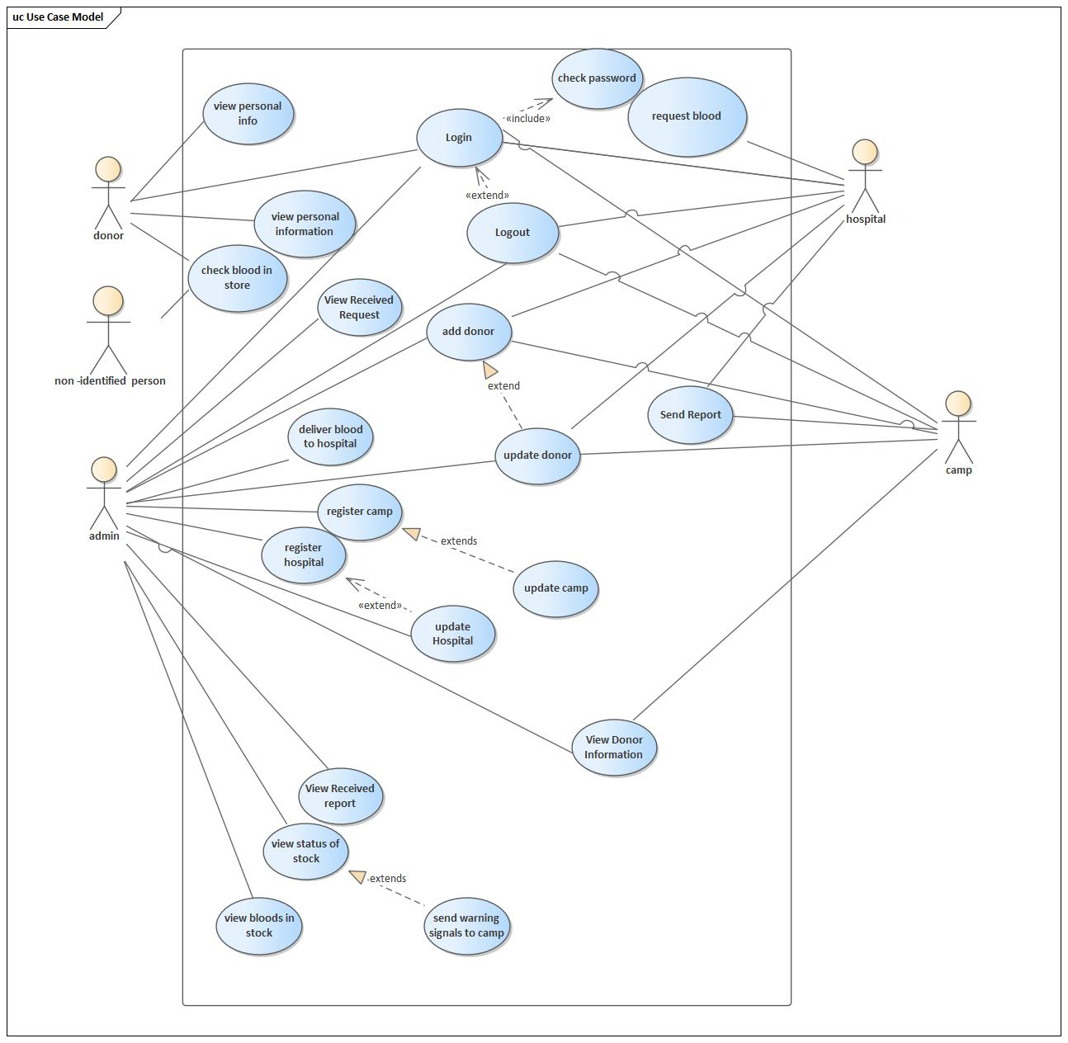

Figure 1. Use case Diagram

**3.4.2.2 Use Case Description**

|  |  |
| --- | --- |
| Use case id | **1** |
| Use case name | **Add Donor** |
| Actor | Camp Hospital And Admin |
| Description | Add Donor is used to add the all personal information of the donor to the database and  To send authentication the donor. |
| Precondition | * Internet connection should be available. * They have to navigate to BBMS’s URL * The user should have valid username and password and must login |
| Post condition | Donor registered and he/she gets authentication. |
| Normal flow | 1. The user signs into his page 2. Chooses Add donor tab from Donor category 3. The system displays Form to enter the information about the donor. 4. The user fills the information on the form properly. 5. Click Save button and automatically the system sends credential information’s to the donors phone number. |
| Exceptional flow | If the user fills incorrect format on the form, the system pops up with information “Please fill up the correct information” then the user corrects it by clicking OK button. |

Table 5. Use case description for Add donor.

|  |  |
| --- | --- |
| Use case id | **2** |
| Use case name | **Log In** |
| Actor | All Users |
| Description | Login page to log in the backend page |
| Precondition | * Internet connection should be available. * They have to navigate to BBMS’s URL * The user should have valid username and password |
| Post condition | Login to the actor page/leave from page. |
| Normal flow | 1. The user signs into his page 2. Chooses Add donor tab from Donor category 3. The system displays Form to enter the information about the donor. 4. The user fills the information on the form properly. 5. Click Save button and automatically the system sends credential information’s to the donors phone number. |

Table 6. Use case description for login.

|  |  |
| --- | --- |
| Use case id | **3** |
| Use case name | **Update Donors** |
| Actor | Admin Hospital And Camp |
| Description | Update Donor is used for updating the information of the donor. |
| Precondition | * Internet connection should be available. * They have to navigate to BBMS’s URL * The user should have valid username and password and must login |
| Post condition | Update the donor’s related information |
| Normal flow | 1. The user signs into his page 2. Chooses Update donor tab from Donor category 3. On the search bar the user enters Donor id number. 4. The user click SEARCH button. 5. The system displays the Form that contains the information about the donor. 6. The user updates the information on the form properly. 7. Click Save button |
| Exceptional flow | If the user fills incorrect format on the form, the system pops up with information “Please fill up the correct information” then the user corrects it by clicking OK button. |

Table 7. Use case description for update donor.

|  |  |
| --- | --- |
| Use case id | **4** |
| Use case name | **View Personal Information** |
| Actor | Donor |
| Description | View Personal Information will make the donor able to see his/her personal information’s. |
| Precondition | * Internet connection should be available. * They have to navigate to BBMS’s URL * The user should have valid username and password and must login |
| Post condition | the donor see his/her personal information |
| Normal flow | 1. The user opens the system 2. Login to his/her page 3. The system displays his/her personal information on the dashboard. |

Table 8. Use case description for view personal information.

|  |  |
| --- | --- |
| Use case id | **5** |
| Use case name | **View Donor Information** |
| Actor | Admin |
| Description | View Donor Information will let the admin watch the all information about the donor by using his/her id. |
| Precondition | * Internet connection should be available. * They have to navigate to BBMS’s URL * The user should have valid username and password and must login |
| Post condition | The donor will see the available personal information’s. |
| Normal flow | 1. The user signs into his page 2. Chooses View donor information tab from Donor category 3. On the search bar the user enters Donor id number. 4. The user click SEARCH button. 5. The system displays the information about the donor. |
| Exceptional flow | If the user fills incorrect id number on the search bar, the system pops up with information “No donor with this id number” then the user corrects it by clicking OK button. |

Table 9. Use case description for view donor information.

|  |  |
| --- | --- |
| Use case id | **6** |
| Use case name | **Send Report** |
| Actor | Camp And Hospital |
| Description | Send Report to send the daily report about the donate bloods. |
| Precondition | * Internet connection should be available. * They have to navigate to BBMS’s URL * The user should have valid username and password and must login |
| Post condition | Send the daily report to the admin. |
| Normal flow | 1. The user signs into his page 2. Chooses send report tab from Report category 3. The system displays the report form. 4. The user writes the report on the provided form. 5. The user click send button. |

Table 10. Use case description for send report.

|  |  |
| --- | --- |
| Use case id | **7** |
| Use case name | **View Received Report** |
| Actor | Admin |
| Description | View Received Report will let the admin watch the daily report. |
| Precondition | * Internet connection should be available. * They have to navigate to BBMS’s URL * The user should have valid username and password and must login |
| Post condition | The daily report will be sent to the admin. |
| Normal flow | 1. The user signs into his page 2. Chooses received reports tab from Report category 3. The system displays the received reports. 4. The user selects one report from list of report. 5. The system displays the selected report. |
| Exceptional flow | If the system pops up with information “there is no received reports” if there is no one reports. |

Table 11. Use case description for view received report.

|  |  |
| --- | --- |
| Use case id | **8** |
| Use case name | **Check Blood In Store** |
| Actor | DONOR |
| Description | Check Blood In Store is used to let the donor check the blood in the store. |
| Precondition | * Internet connection should be available. * They have to navigate to BBMS’s URL * The user should have valid username and password and must login |
| Post condition | The donor will check the blood in the store. |
| Normal flow | 1. The user signs into his page 2. The user Clicks Check button from Top right category 3. The system displays the page which contain selection combo box. 4. The user selects one type of blood type from the combo box. 5. The system displays the availability of the selected blood type. |

Table 12. Use case description for check blood in store.

|  |  |
| --- | --- |
| Use case id | **9** |
| Use case name | **View Received Report** |
| Actor | Unidentified User |
| Description | View Received Report will let the admin watch the daily report. |
| Precondition | * Internet connection should be available. * They have to navigate to BBMS’s URL |
| Post condition | Watch the daily report from the camp and hospital. |
| Normal flow | 1. The user Clicks Check button from Top right category 2. The system displays the page which contain selection combo box. 3. The user selects one type of blood type from the combo box. 4. The system displays the availability of the selected blood type. |

|  |  |
| --- | --- |
| Use case id | **10** |
| Use case name | **Request Blood** |
| Actor | Hospital |
| Description | Request Blood used for hospitals to make a blood request to the admin. |
| Precondition | * Internet connection should be available. * They have to navigate to BBMS’s URL * The user should have valid username and password and must login |
| Post condition | Hospitals send a blood requests to the admin. |
| Normal flow | 1. The user signs into his page 2. Chooses Request tab 3. The system displays the request form. 4. The user writes the requested blood type and amount of units required. 5. The user Clicks SEND REQUEST. |

Table 13. Use case description for request blood.

|  |  |
| --- | --- |
| Use case id | **11** |
| Use case name | **Register Camp** |
| Actor | Admin |
| Description | Register Camp to create a camp by giving a credential information. |
| Precondition | * Internet connection should be available. * They have to navigate to BBMS’s URL * The user should have valid username and password and must login |
| Post condition | Register, assign the camps and also add the camps to the system. |
| Normal flow | 1. The user signs into his page 2. Chooses Register Camp tab from Register category 3. The system displays Form to enter the information about the Camp. 4. The user fills the information on the form properly. 5. Click REGISTER button and automatically the system generates credential information’s for the camp. |
| Exceptional flow | If the user fills incorrect format on the form, the system pops up with information “Please fill up the correct information” then the user corrects it by clicking OK button. |

Table 14. Use case description for register camp.

|  |  |
| --- | --- |
| Use case id | **12** |
| Use case name | **Register Hospital** |
| Actor | Admin |
| Description | Register Hospital used for including the hospital to the system by giving authentication. |
| Precondition | * Internet connection should be available. * They have to navigate to BBMS’s URL * The user should have valid username and password and must login |
| Post condition | Register and add the hospitals to the system. |
| Normal flow | 1. The user signs into his page 2. Chooses Register Hospital tab from Register category 3. The system displays Form to enter the information about the Hospital. 4. The user fills the information on the form properly. 5. Click REGISTER button and automatically the system generates credential information’s for the Hospital. |
| Exceptional flow | If the user fills incorrect format on the form, the system pops up with information “Please fill up the correct information” then the user corrects it by clicking OK button. |

Table 15. Use case description for register hospital.

|  |  |
| --- | --- |
| Use case id | **13** |
| Use case name | **Update Hospital** |
| Actor | Admin |
| Description | Update Hospital used for to update hospital’s records. |
| Precondition | * Internet connection should be available. * They have to navigate to BBMS’s URL * The user should have valid username and password and must login |
| Post condition | Update hospital related attributes. |
| Normal flow | 1. The user signs into his page 2. Chooses update Hospital tab from Update category 3. On the search bar the user enters Hospital id number. 4. The system displays the Form that contains the information about the Hospital. 5. The user updates the information on the form properly. 6. Click Save button |
| Exceptional flow | If the user fills incorrect format on the form, the system pops up with information “Please fill up the correct information” then the user corrects it by clicking OK button. |

Table 16. Use case description for update hospital.

|  |  |
| --- | --- |
| Use case id | **14** |
| Use case name | **Update Camp** |
| Actor | Admin |
| Description | Update camp used for to update camp’s records. |
| Precondition | * Internet connection should be available. * They have to navigate to BBMS’s URL * The user should have valid username and password and must login |
| Post condition | Update camp related attributes. |
| Normal flow | 1. The user signs into his page 2. Chooses update Camp tab from Update category 3. On the search bar the user enters Camp id number. 4. The system displays the Form that contains the information about the Camp. 5. The user updates the information on the form properly. 6. Click Save button |
| Exceptional flow | If the user fills incorrect format on the form, the system pops up with information “Please fill up the correct information” then the user corrects it by clicking OK button. |

Table 17. Use case description for update camp.

|  |  |
| --- | --- |
| Use case id | **15** |
| Use case name | **View Status Of The Stock** |
| Actor | Admin |
| Description | View status of the stock will make the admin to be able to see the available bloods with their amount of unit. |
| Precondition | * Internet connection should be available. * They have to navigate to BBMS’s URL * The user should have valid username and password and must login |
| Post condition | Watch the available amount of blood units. |
| Normal flow | 1. The user signs into his page 2. Chooses View Status tab from Stock category 3. The system displays the status of the Stock. |

Table 18. Use case description for view status of stock.

|  |  |
| --- | --- |
| Use case id | **16** |
| Use case name | **Send Warning Signal To Hospitals And Camps** |
| Actor | Admin |
| Description | These used for sending a warning signal to hospitals and camps when there is shortage in the blood store. |
| Precondition | * Internet connection should be available. * They have to navigate to BBMS’s URL * The user should have valid username and password and must login |
| Post condition | Send a signal to the hospital and camps. |
| Normal flow | 1. The user signs into his page 2. Chooses View Status tab from Stock category 3. The system displays the status page. 4. If the status of the page is risky then the user clicks the WARNING button found at the bottom right corner. |
| Exceptional flow | If the status of the page is not risky or normal then the system inactive WARNING button found at the bottom right corner. |

Table 19. Use case description for send warning signal to hospital and camp.

|  |  |
| --- | --- |
| Use case id | **17** |
| Use case name | **View Bloods In Stock** |
| Actor | Admin |
| Description | View bloods in stock used for to watch the blood related information in the store. |
| Precondition | * Internet connection should be available. * They have to navigate to BBMS’s URL * The user should have valid username and password and must login |
| Post condition | Watch the whole blood related information in the store. |
| Normal flow | 1. The user signs into his page 2. Chooses View bloods in stock tab from Stock category 3. The system displays the blood in stock in arranged form in terms of its blood units and blood types. |
| Exceptional flow | If the stock does not have any bloods in it the system does not display anything. |

Table 20. Use case description for send warning signal to view bloods in stock.

|  |  |
| --- | --- |
| Use case id | **18** |
| Use case name | **View The Received Request** |
| Actor | Admin |
| Description | These used for To watch the request from the hospital. |
| Precondition | * Internet connection should be available. * They have to navigate to BBMS’s URL * The user should have valid username and password and must login |
| Post condition | Watch the sent request from the hospital. |
| Normal flow | 1. The user signs into his page 2. Chooses requests tab from Request category 3. The user selects one request from the lists of requests. |
| Exceptional flow | If there is no requests received the system pops up with “there is no requests received” then the user clicks OK button and returns to the previous position. |

Table 21. Use case description for view received request.

|  |  |
| --- | --- |
| Use case id | **19** |
| Use case name | **Deliver Blood To Hospital** |
| Actor | Admin |
| Description | Deliver blood to hospital is used for to respond the request of the hospital. |
| Precondition | * Internet connection should be available. * They have to navigate to BBMS’s URL * The user should have valid username and password and must login |
| Post condition | Send a response to the request of the hospital. |
| Normal flow | 1. The user signs into his page 2. Chooses requests tab from Request category 3. The user selects the first request from the lists of requests. 4. At the bottom right corner the user clicks DELIVER button 5. The system displays the deliver form for the user. 6. The user fills the form and click SEND. |
| Exceptional flow | If the user fills incorrect format on the form, the system pops up with information “Please fill up the correct information” then the user corrects it by clicking OK button. |

Table 22. Use case description for deliver blood to hospital.

**3.5 Object model**

**3.5.1 Data Dictionary**

|  |  |  |  |
| --- | --- | --- | --- |
| **Classes** | Attributes | Operations | Description |
| **login** | Id,password | Authenticate()  login() | used to enter into the system by their authentication |
| **Personal Info** | Address,phone,sex,  Name | - | is info all peoples interacting in the system |
| **donor** | blood_type,donor_id  donatedTimes | login()  CheckBlood()  viewPersonalInfo() | is the info of donor |
| **register** | Address,id | register() | is Addition of new hospital,camp into th e system |
| **camp_worker** | camp_id  camp_password | AddDonor()  login()  sendReport()  updateDonor()  viewDonorInfo() | is the info of the camp workers and their functions |
| **camp** | assigned_date,camp_id,  sendReport | SendReport()  registerDonor() | is the place where bloods are collected outside of the blood bank by building tents on the street. |
| **report** | report_id,reportDate,  repertContent | ReceiveReport()  sendReport()  ViewReport() | is the report which is sent to the blood bank which contains daily records of donations. |
| **Request** | RequestedBloodType,  requestedBloodUnit | ReceiveRequest()  SendRequest()  viewRequest() | is the request apprehended by the hospital for the blood bank for the delivery of the blood |
| **Warning Signal** | warningInfo | sendWarning() | is the warning sent to the hospital and camps inorder to collect the bloods which is deficient in the stock. |
| **Blood** | BloodType,bloodUnit,  ExpireDate | DeliverBlood()  sendBlood() | is the lifeline of the the human being |
| **Blood Stock** | BloodType,bloodUnit | AddBlood()  DeliverBlood()  viewStatusOfStock() | is the place where the collected blood is stored. |
| **Hospital** | hospital_id,  sendReport,  sendRequest | ReceiveWarning()  sendReport()  storeBlood() | is the entity in which peoples are treated and blood transfusion takes place. |
| **Hospital worker** | emp_id,  empPassword | AddDonor()  login()  RequestBlood()  SendReport()  updateDonor() | is the person which admnisters a blood banks hospital catagories |
| **administrator** | emp_id,  empPassword | RegisterCamp()  RegisterHospitals()  sendWarning()  updateCampInfo()  updateHospitalnfo()  viewDonorInfo()  viewReceivedReport()  viewReceivedReqeust() | is the person who have more acces on the blood bank management system |
| **Blood Bank** | Address,branch_id,  contact_no | Name()  recieveReport()  storeBlood()  receiveRequst()  viewBloodStock | is the entity intended to do different functions and it is the institution which this management system is made for. |

Table 23. Data dictionary.

**3.6.2 Class Diagram**

The Class diagram captures the logical structure of the system; the classes and things that make up the model. It is a static model, describing what exists and what attributes and behavior it has, rather than how something is done. Class diagrams are most useful to illustrate relationships between classes and interfaces.

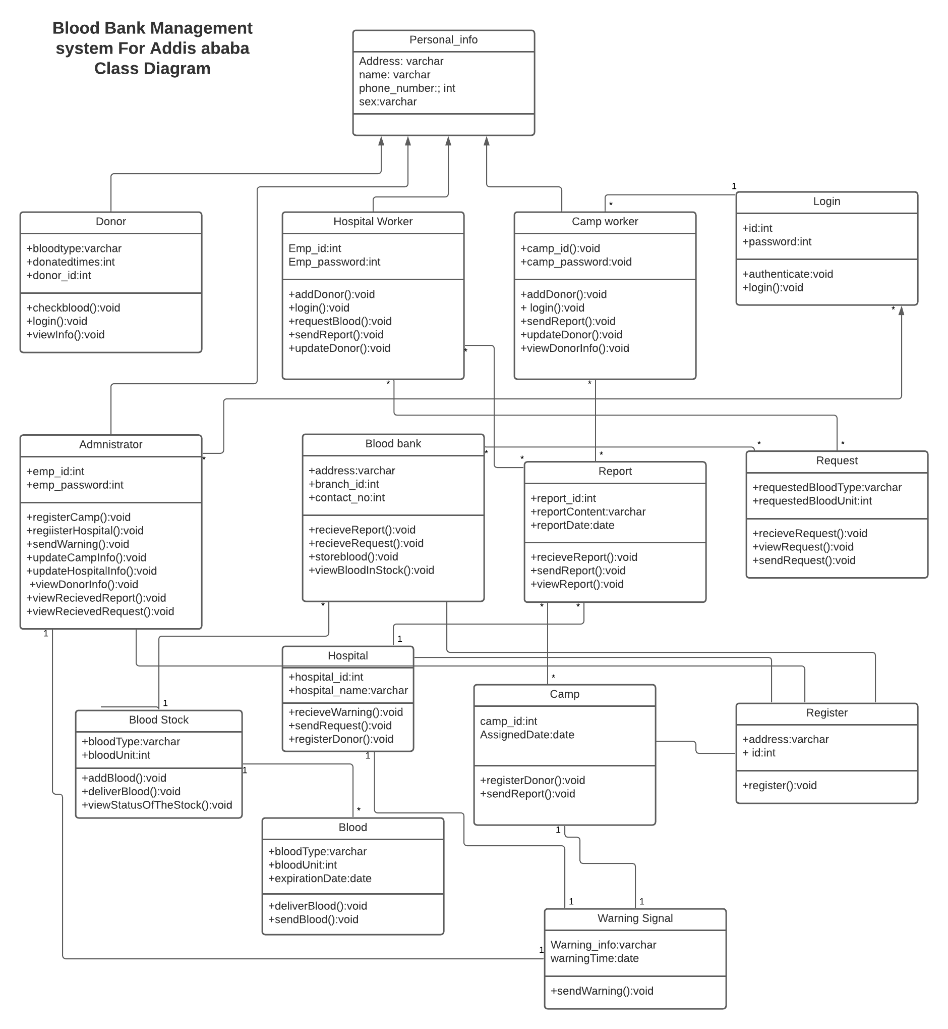

Figure 2. Class Diagram

**3.5.3 Dynamic model**

**3.5.4 Sequence diagrams**

Sequence diagrams in the UML are primarily used to model the interactions between the actors and the objects in a system and the interactions between the objects themselves. As the name implies, a sequence diagram shows the sequence of interactions that take place during a particular use case or use case instance. The objects and actors involved are listed along the top of the diagram, with a dotted line drawn vertically from these. Interactions between objects are indicated by annotated arrows. The rectangle on the dotted lines indicates the lifeline of the object concerned. The annotations on the arrows indicate the calls to the objects, their parameters, and the return values.

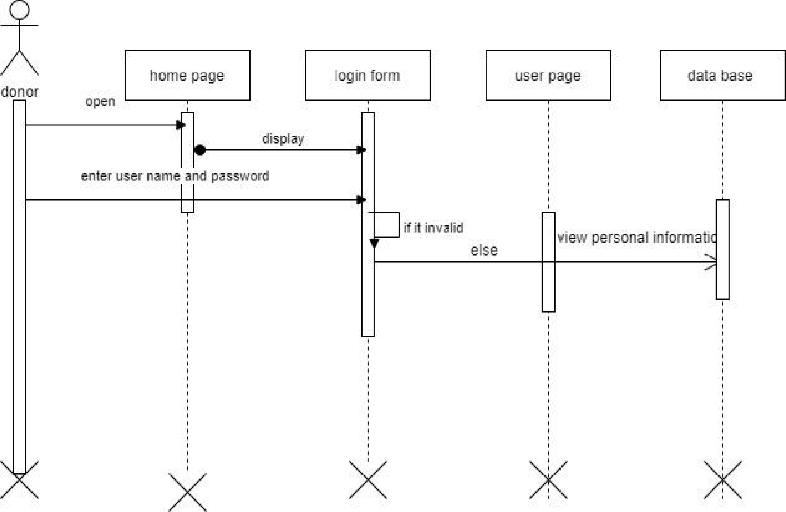

Figure 3. Sequence diagram for Donor view personal information.

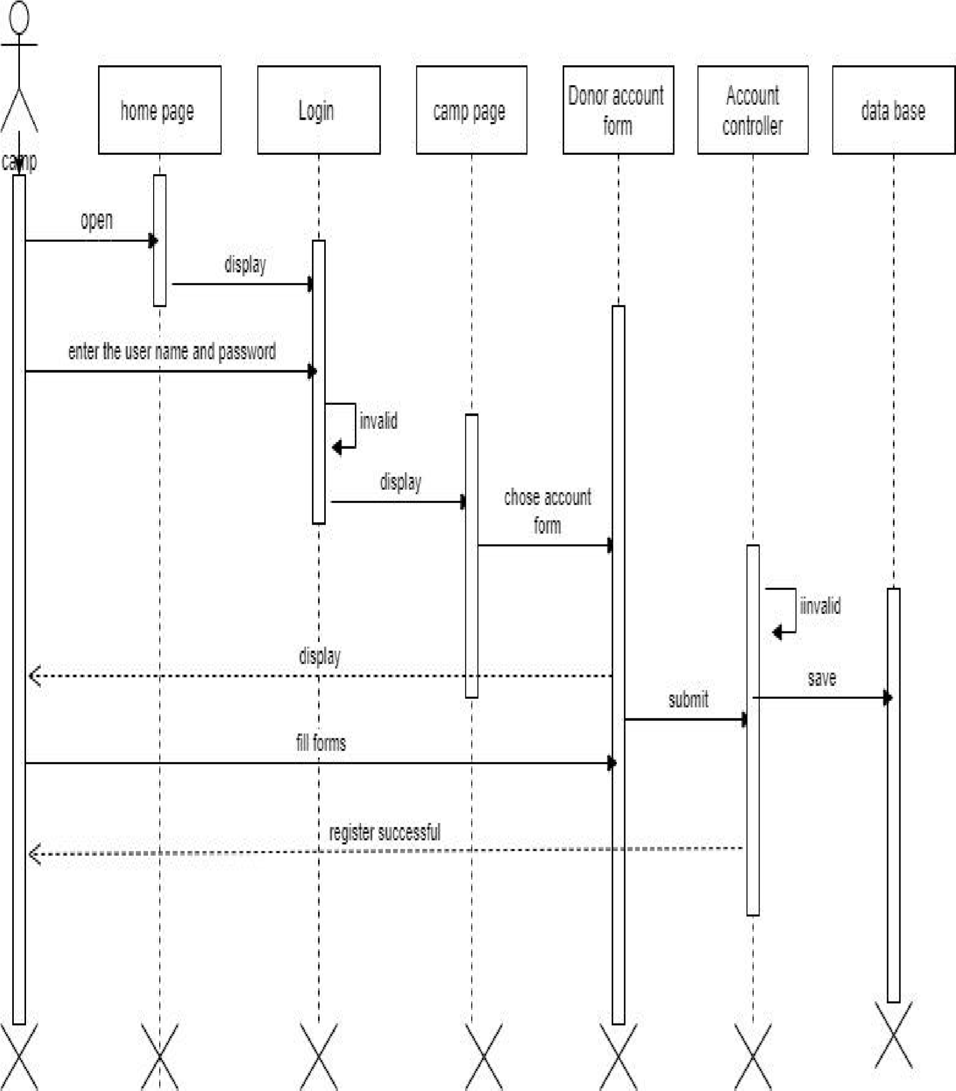

Figure 4. Sequence diagram for Donor register.

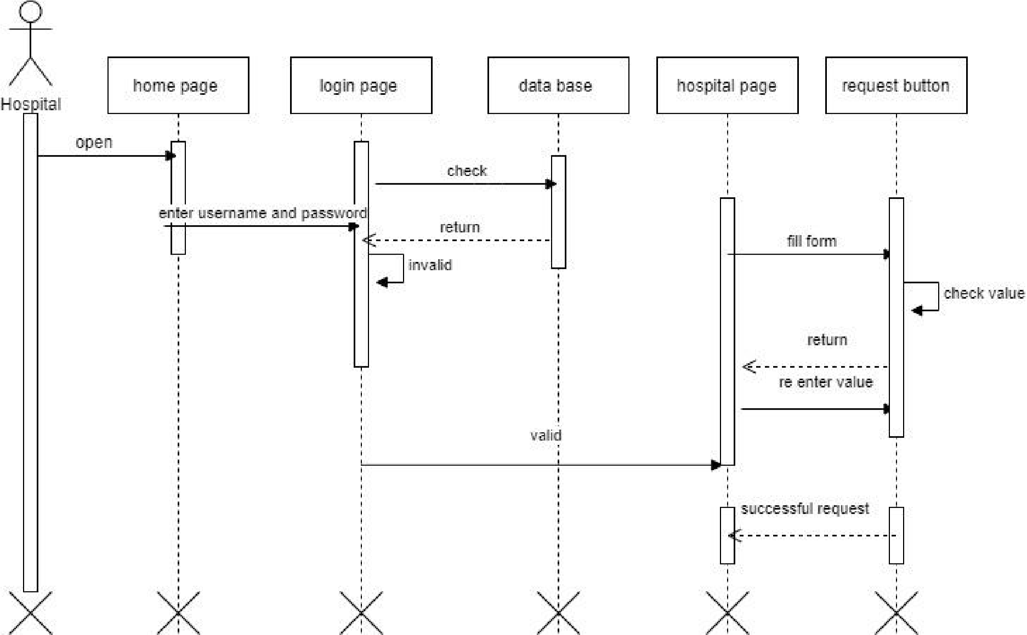

Figure 5. Sequence diagram for Request Blood.

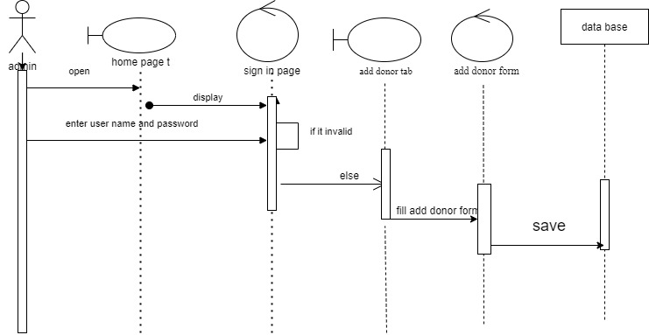

Figure 6. Sequence diagram for Register donor

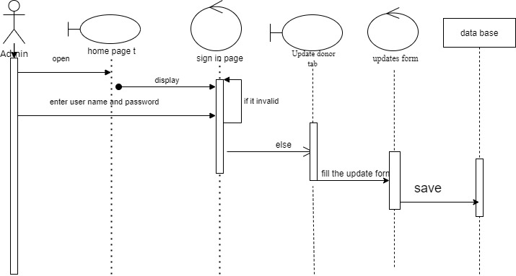

Figure 7. Sequence diagram for update donor.

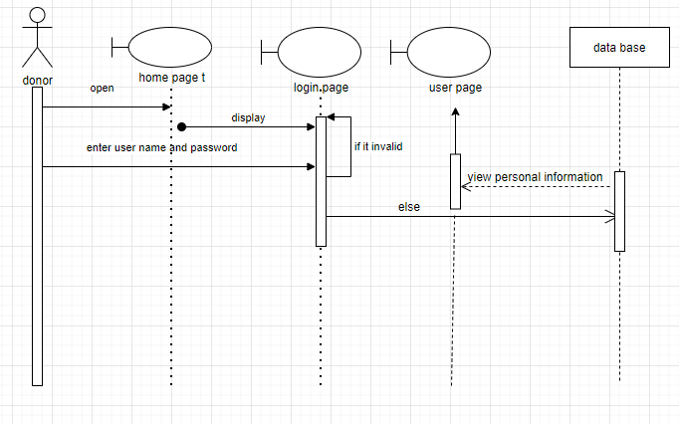

Figure 8. Sequence diagram for **View Personal Information**

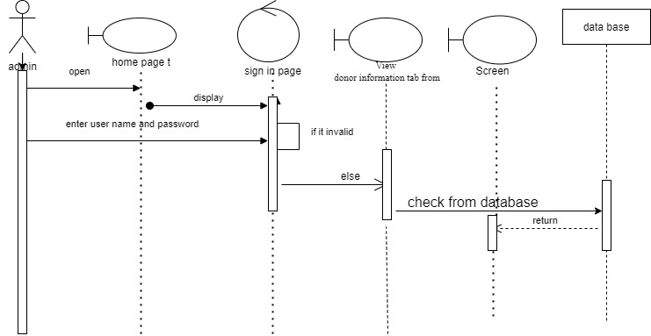

Figure 9. Sequence diagram for **View donor Information**

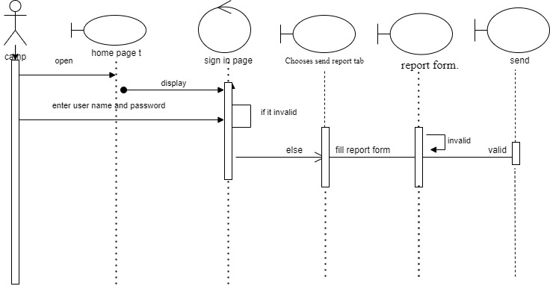

Figure 10. Sequence diagram for **send report**

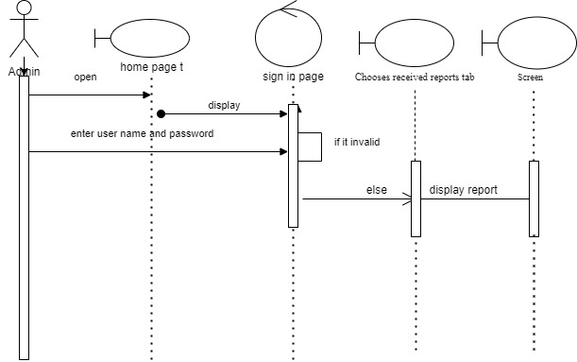

Figure 11. Sequence diagram for **View Received Report**

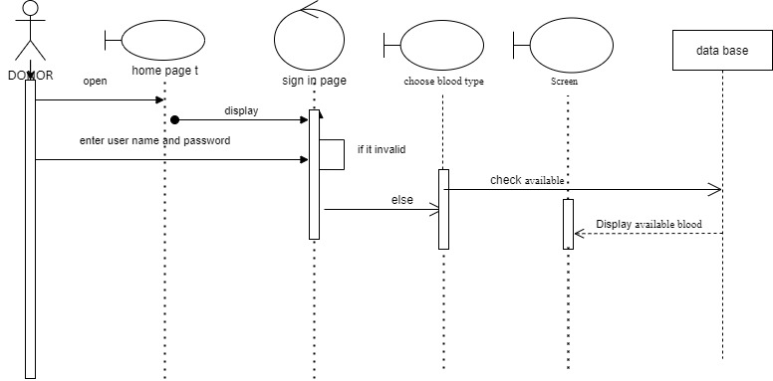

Figure 12. Sequence diagram for **Check Blood In Store**

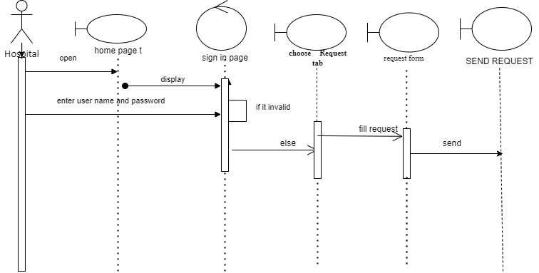

Figure 13. Sequence diagram for **Request Blood**

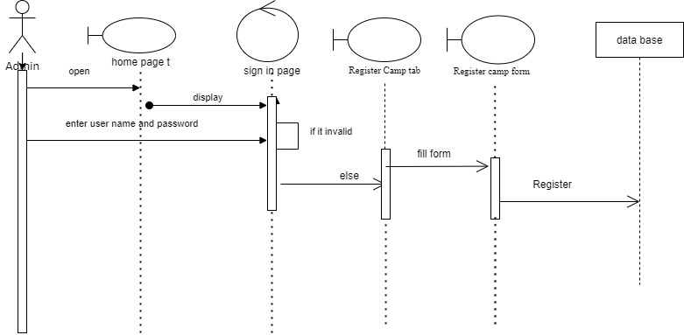

Figure 14. Sequence diagram for **Register Camp**

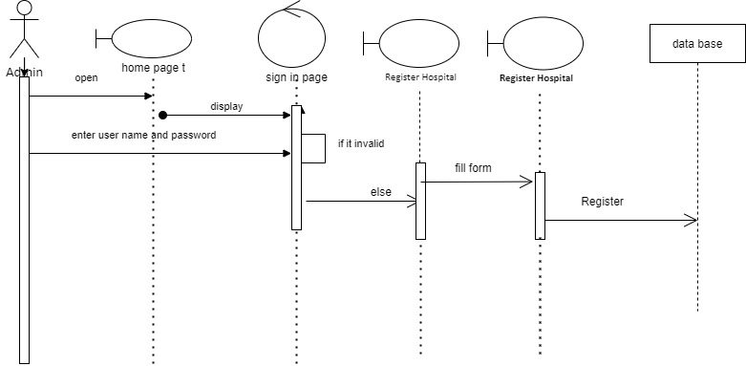

Figure 15.Sequence diagram for **Register Hospital**

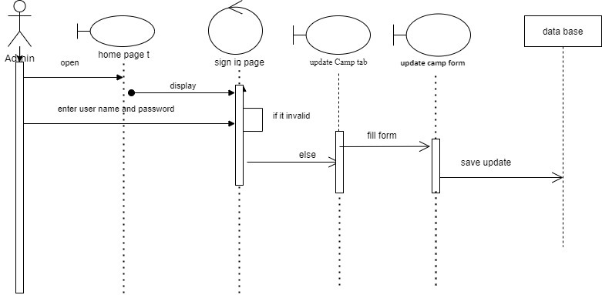

Figure 16. Sequence diagram for **Update Camp**

**3.5.4 Activity diagram**

**Activity diagrams** are graphical representations of workflows of stepwise activities and actions with support for choice, iteration and concurrency. And show the overall flow of control.

Activity diagrams are constructed from a limited number of shapes, connected with arrows. The most important shape types:

* *rounded rectangles* represent *actions*;
* *diamonds* represent *decisions*;
* a *black circle* represents the start (*initial node*) of the workflow;
* an *encircled black circle* represents the end (*final node*).
* arrows run from the start towards the end and represent the order in which activities happen.



Figure 17. Activity diagram for add donor



Figure 18. Activity diagram for Request Blood



Figure 19. Activity diagram for Register hospital



Figure 20. Activity diagram for update hospital



Figure 21. Activity diagram for sending warning message to hospital and camp

**uc Activity**



**open login page**



**Enter user name and**

**password**



check validity



**Fill The Request form**



**View response**



*request blood*

invalid

Figure 22. Activity diagram for request blood

**uc Activity**



**open login page**



**Enter username and**

**password**



check validity



**Register camp**



**Update donor**



*register Camp*

invalid

Figure 23. Activity diagram for register camp

**uc activity**



**open login page**



ObjectNode1



**donor fill user name and**

**password**



check validity



**display requested actor**

**page**



Activity Final

*viewing blood in stock*

invalid

Figure 24. Activity diagram for view blood in stock

Figure 25. Activity diagram for view report.

**uc activity**



**open login form**



**Enter the user name and**

**password**



check password



**select view report**



**display report**



*Viewing report.*

invalid



Figure 26. Activity diagram for update donor.



Figure 27. Activity diagram for user login.

**3.6.3. State chart diagram**

**State chart diagram** is one of the five UML diagrams used to model the dynamic nature of a system. They define different states of an object during its lifetime and these states are changed by events. State chart diagrams are useful to model the reactive systems. Reactive systems can be defined as a system that responds to external or internal events.

**State chart Diagrams Basics**

* States and Events
* Transitions
* Actions
* Synchronization Bars
* Decision Points
* Complex States  
   • Composite States  
   • Concurrent Sub states  
   • History States  
   • Synch States
* Transitions to and from Composite States.

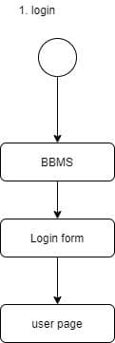

Figure 28. state chart diagram for user login.

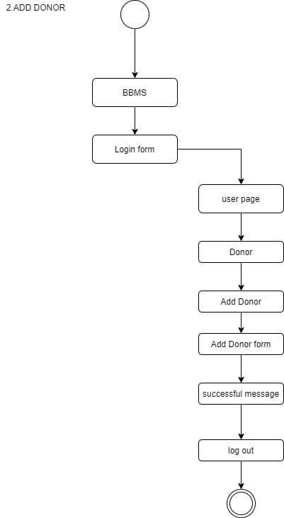

Figure 29. State chart diagram for Add donor

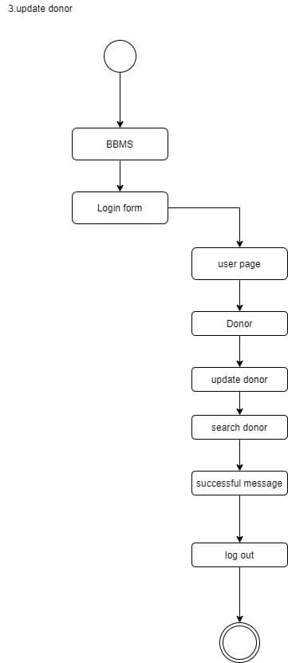

Figure 30. State chart diagram for update donor.

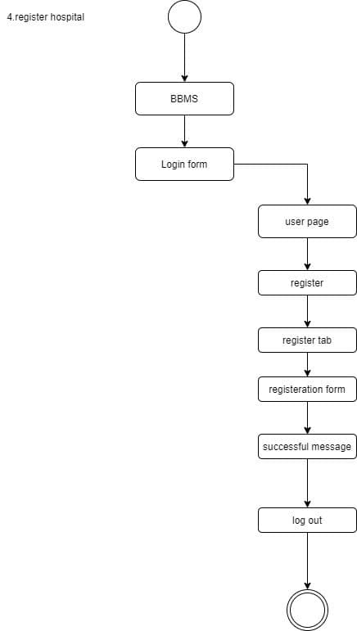

Figure 31. State chart diagram for register hospital.

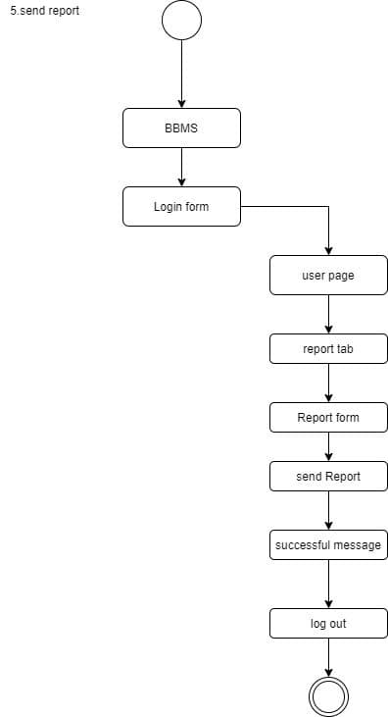

Figure 32. State chart diagram for send report.

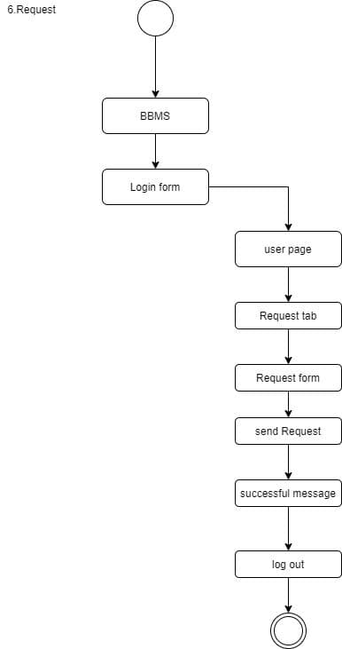Figure 33. State chart diagram for request blood.

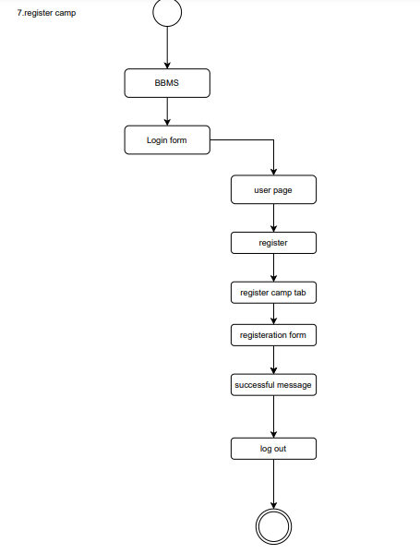

Figure 34. State chart diagram for register camp.

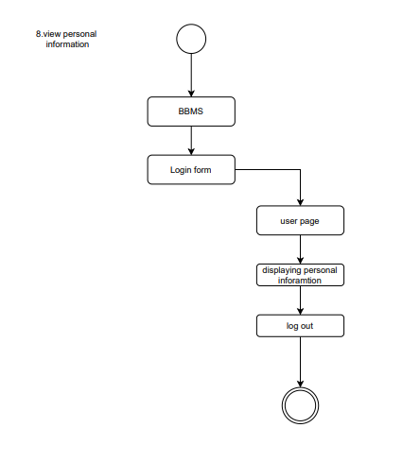

Figure 35. State chart diagram for view personal information.

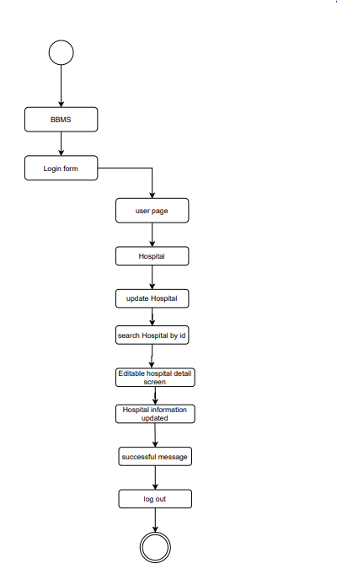 Figure 36. State chart diagram for update hospital.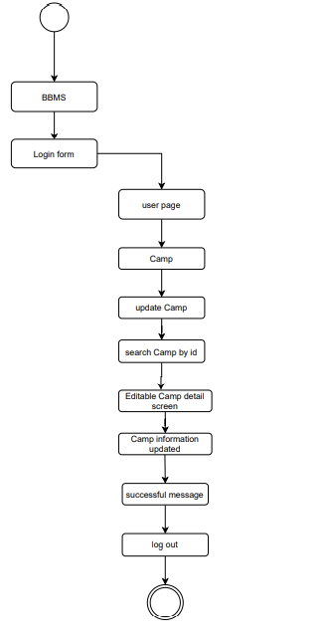 Figure 37. State chart diagram for update camp.

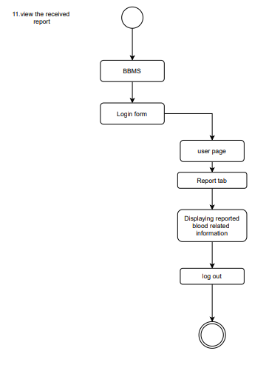

Figure 38. State chart diagram for view received report.

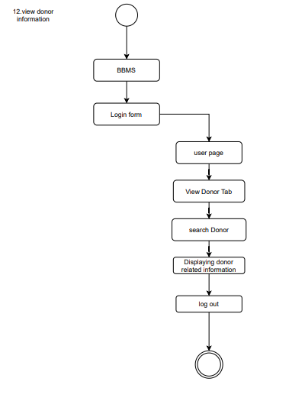

Figure 39. State chart diagram for view donor information.

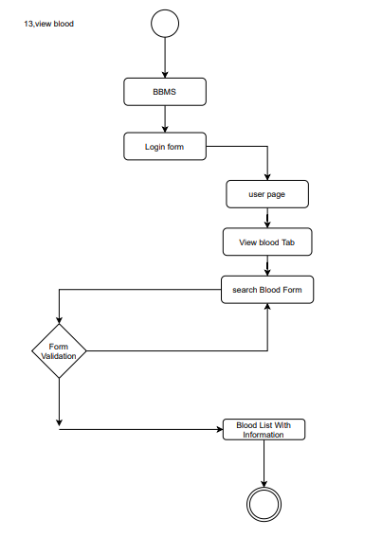

Figure 40. State chart diagram for view blood in stock.

**Chapter Four**

**4.1 Overview**

This is the system design document to the Distributed Blood Bank System for Addis Ababa region. The document includes the design goals, the proposed system Design and the object design.

**4.1.1 Purpose of the System design**

This document describes the design issues of the overall system. It provides the complete architectural overview of the proposed system. It is intended to capture and express the significant architectural decisions which have been made on the system.

**4.1.2 Design Goal**

The Design Goals specify the qualities of the system that should be achieved and addressed during the design of the system.it The design goals describe the qualities of the system that are derived from the non-functional requirements which can lead to decisions of developers. The design goals for the system are grouped into four categories. These are:

* Performance
* Dependability
* Maintenance
* End use

**Performance**

In order for the Ethiopian blood bank management system to work effectively it should satisfy the following performance criteria’s

* **Response time:** if there is a good connection at where the system machine is the system is going to interact and respond to user’s request in a maximum of 15 second.
* **Memory:-**The client system requires an average of 10-15 megabits of RAM memory to be loaded on a user’s web browser and streaming of trailers require additional memory up to 20 megabits. The server system is going to require up to 40 GB of memory to store all the data and other components of the system.

**Dependability**

Ethiopian blood bank management system should achieve the following dependability properties in order to resist the crash of the system.

* **Robustness**: since the management system is web based system during the interaction with the system there wouldn’t be that much problem by the user side.
* **Availability**: as long as there is an internet connection the system will be available 7 days a week and 24 hours a day.
* **Security:** BBMS should be secured in a way not to allow other users or unauthorized users to access data that has no the right to access it.
* **Reliability:** the information provided by the system is as reliable as it is presented on the web page interface, and this is maintained by the persistent database.

**Maintenance**

Ethiopian blood bank management system should achieve the following dependability properties in order to resist any failure during any maintenance of the system.

* **Extensibility:** if it is needed to add new functionality to the system, this must be achieved by only making the next version of the application by using update control system.
* **Modifiability:** - if in the system, some functionality requires to be modified, this modification must be done specifically to that function or page without affecting the overall system organization.
* **Portability** the system is developed to be viewed and retrieved from any web browser regardless of their version and platform it resides in it.

**End User**

for the system to give a best service for the user it should achieve the following end user criteria’s

* **Utility**: in order for the user to interact with the system the system interactive language with the user must be pretty simple.
* **Usability**: for the system to enhance the usability of the system it should include the following criteria’s
* Less crowded interface
* Flexibility
* Learnability
* Consistent page pattern

**4.2. Proposed system architecture**

In this project, the team uses a three-tier architecture, which has three layers. These three layers are client side, server side and database

**Client side**: here in the client side Employee, Administrator, and user interface will be existing.

**Server side:** here the web servers to connect the data base application are found; mean that the application logic to perform the application by the client is found.

**Data base**: here the data bases that store the information are found.

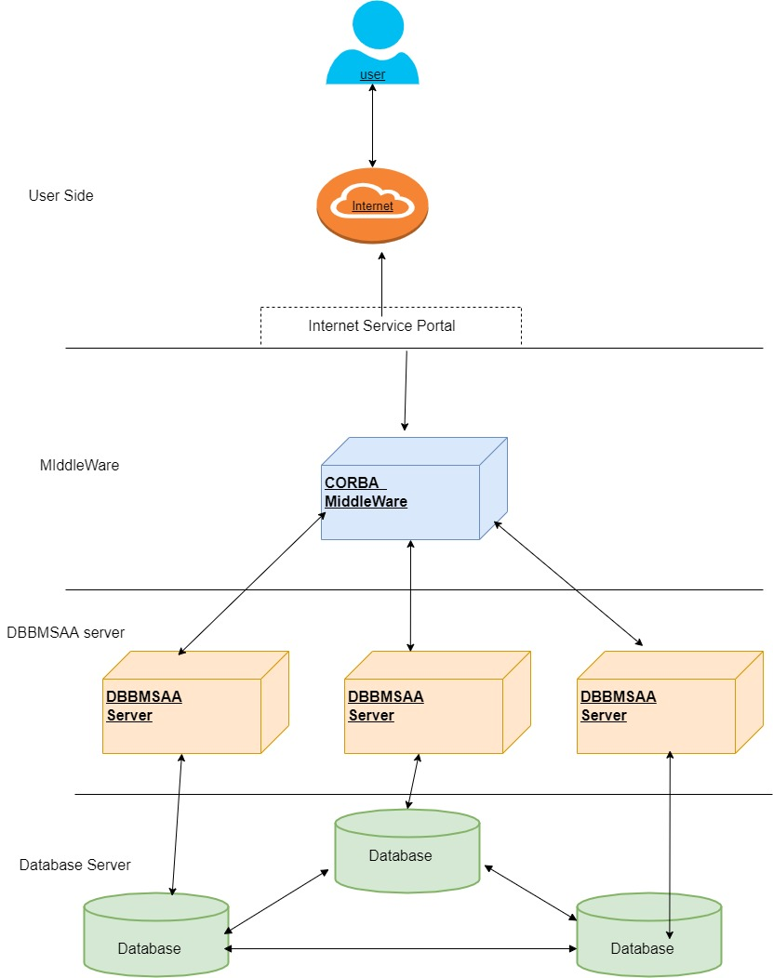

Figure 41. Proposed System Architecture.

**4.2.1. System process**

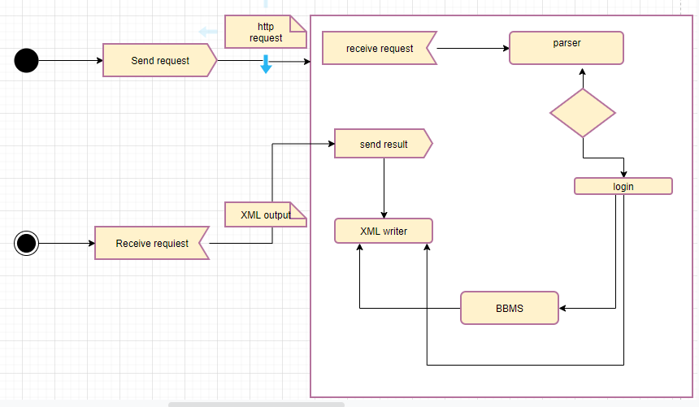

Figure 42. System Activity Diagram.

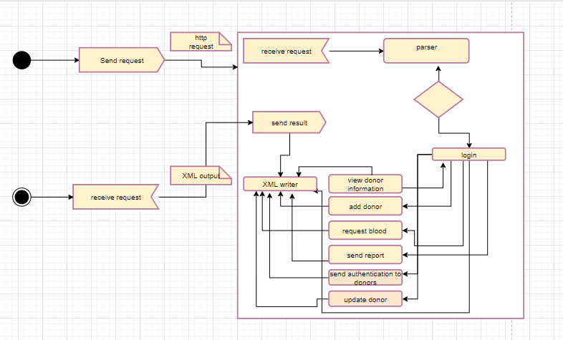

Figure 43. System process diagram for camp

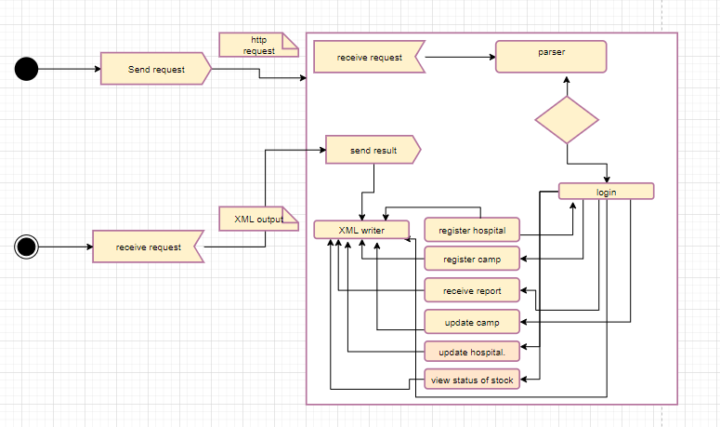

Figure 44. System process diagram for Admin

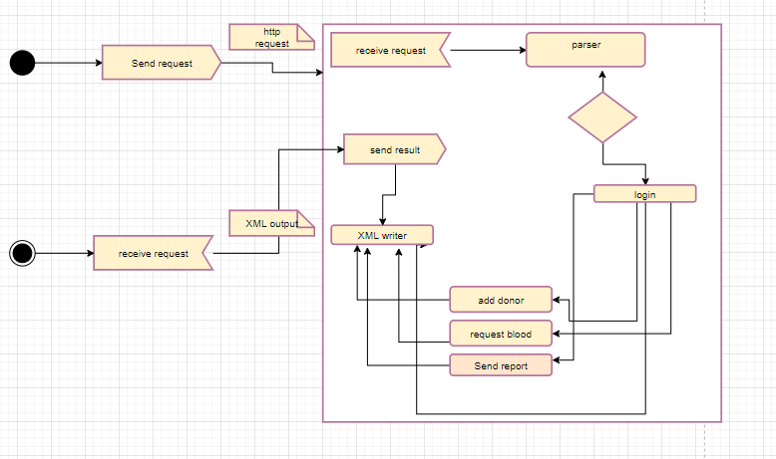

Figure 45. System process diagram for Hospital

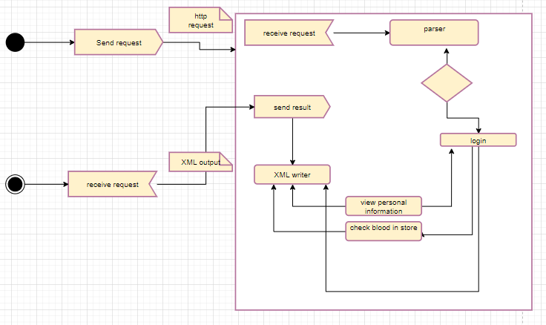

Figure 46. System process diagram for donor

**4.2.2. Subsystem decomposition**

It uses to describe the system in a less complex manner. The subsystem can be considered as packages holding a Collection of classes, associations, operations, and constraints that are closely interrelated with each other

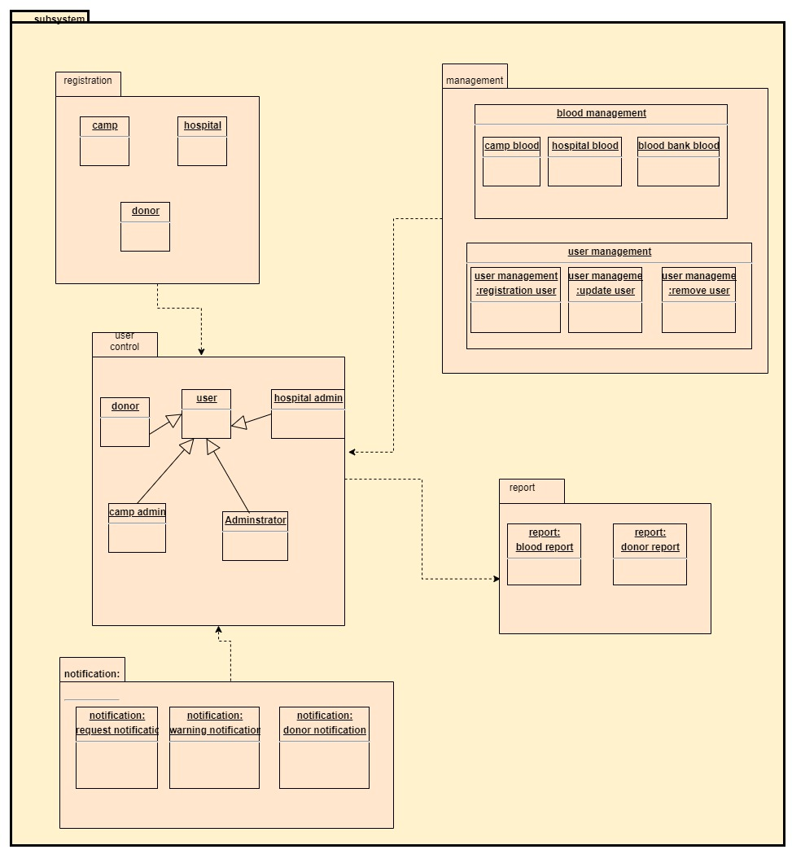` Figure 47. System Subsystem Decomposition

**Subsystem Decomposition Description**

|  |  |  |
| --- | --- | --- |
| **Subsystem** | **purpose** | **Class** |
| **Service management** | The purpose is to handle the management process, which includes managing user and blood. | Registration  Blood transaction  Manage Stock  Blood insertion  Manage user |
| **Report** | The purpose is to generate reports about events and donor, blood. | search |
| **Communication** | The purpose is to handle the communication like notification and Request. | Notification  Request |

Table 23. Subsystem Decomposition Description

**4.2.3 Hardware/software mapping**

The system will have three processes, deployed in single or separate machine, that run in parallel, namely, middleware process, DBBS server process and the database process. The data base process, which runs on Microsoft SQL Server database engine, is responsible for maintaining data manipulation operations. Whereas, the middleware process handles the load balancing and transparency and the DBBS server process is responsible to host the web pages of the system and process clients’ request. In case of the client side, only a browser is required to access the objects.

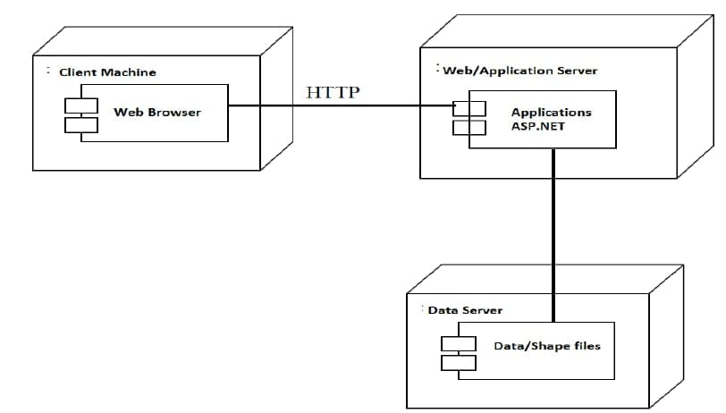

Figure 48. Hardware/software mapping

**4.2.4. Persistent data management**

The purpose of this section is to show the mapping of the objects/classes of the system, identified during the analysis stage, in to the corresponding relational database.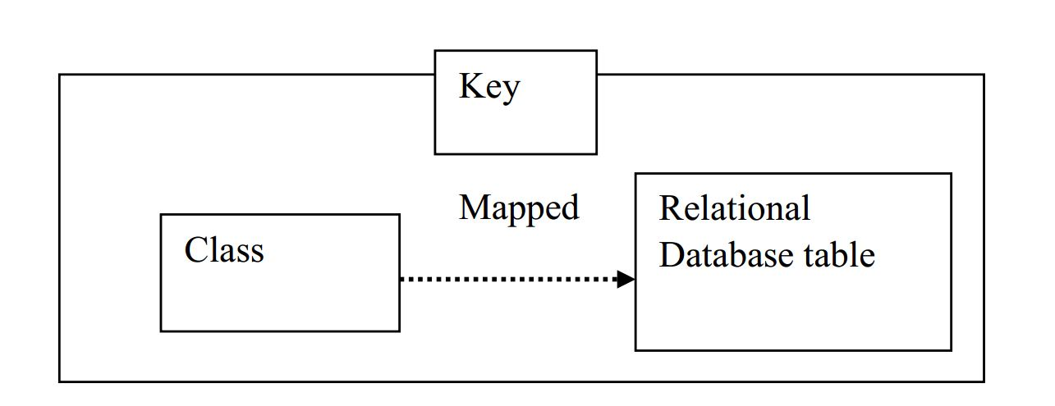

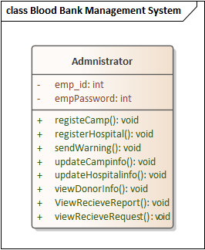 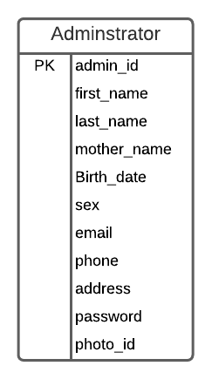

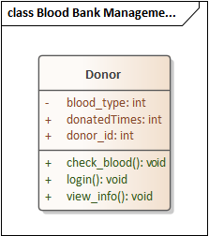 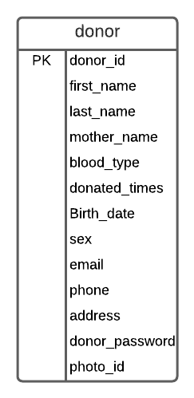

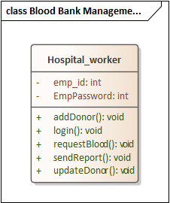 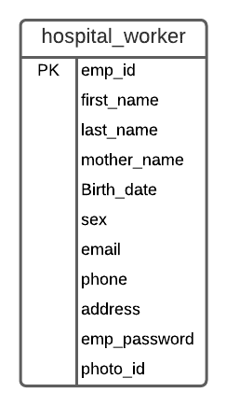

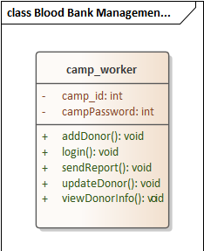 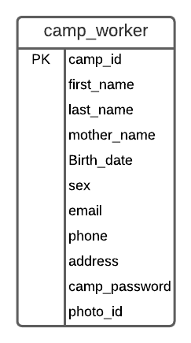

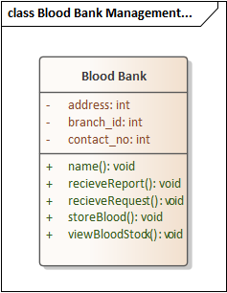 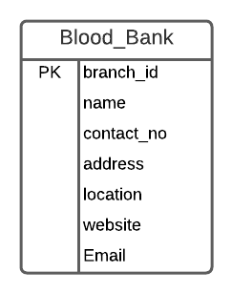

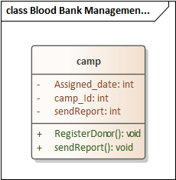 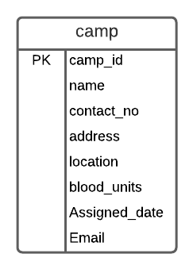

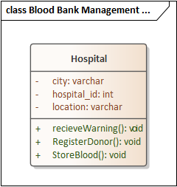 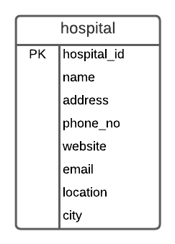

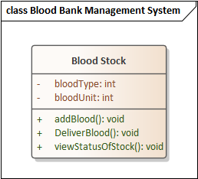 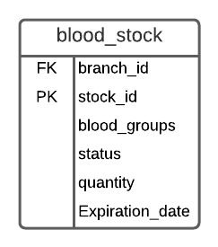

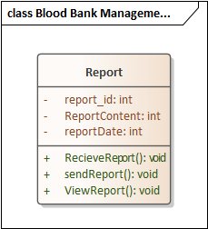 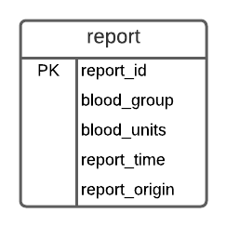

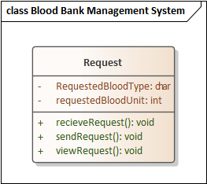 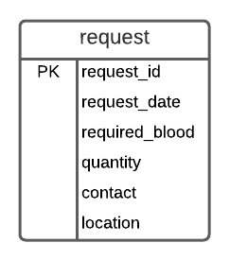

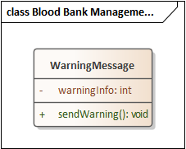 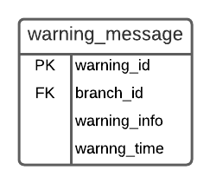

Figure 49. Persistent data management

**4.2.5. Component diagram**

Models the physical implementation of the software (file resources). Models the high-level software components, and their interfaces. Components to use with Component Diagram are:

Components required for running the system (library file, etc.)

Source code file, and data file

Executable file (.exe)

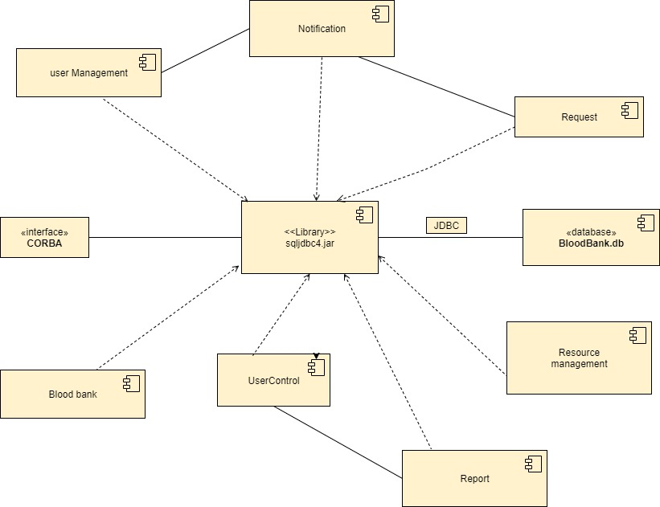

Figure 50. Component diagram

**4.2.6. Deployment diagram**

Describes system hardware, software, and network connections for distributed computing. It covers server configuration and network connections between server nodes in real-world setting.

* They show the structure of the run-time system
* They can be used to plan the architecture of a system.
* Physical machines, devices and processors are reflected as nodes, and the internal construction can be depicted by embedding additional nodes or artifacts.

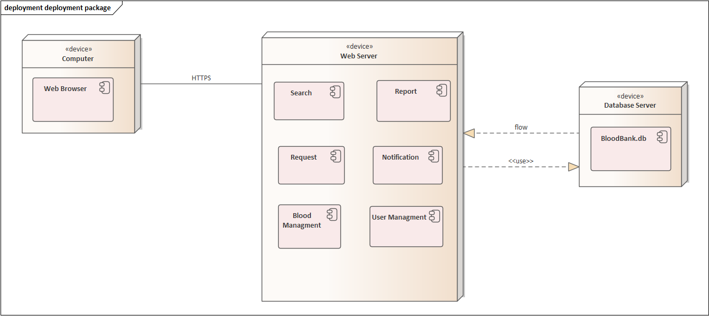

Figure 51. Deployment diagram

**4.2.7. Database design**

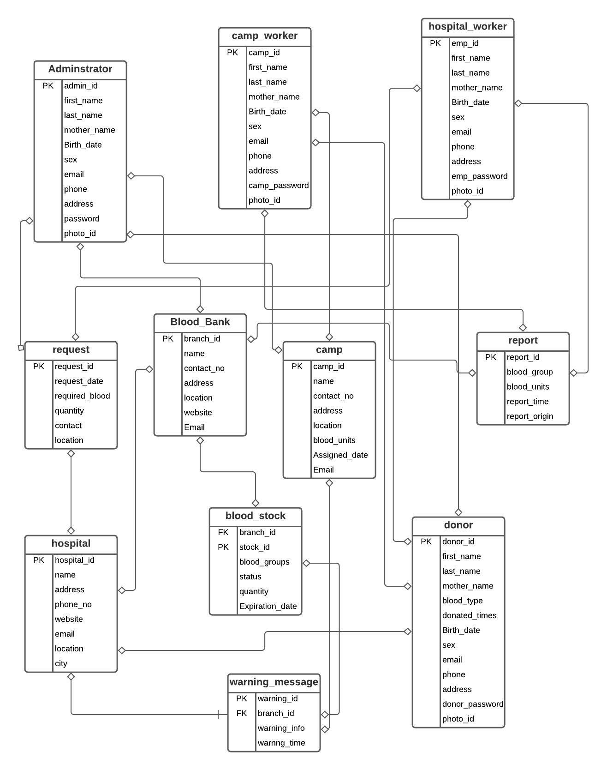

Figure 52. Database design

**4.2.8. Access control**

The table below shows the global access table, describing the access relation between the actors, objects and operations in the system:

|  |  |  |  |
| --- | --- | --- | --- |
| Actors | Classes | | |
| Register | Report | personal_Info |
| Admin | RegisterCamp()  registerHospitals() | View_recieved_report() | View_personalInfo() |
| Donor |  |  | View_info() |
| Camp | RegisterDonor() | SendReport() |  |
| Hospital | RegisterDonor() | SendReport() | update_personal_info() |
| Other non-identified persons |  |  |  |

|  |  |  |  |
| --- | --- | --- | --- |
| Actors | Classes | | |
| Blood_bank | blood_stock | Blood |
| Admin | Add_branch()  remove_branch()  update_branch() | Deliver_blood() |  |
| Donor |  | check_blood() | DonateBlood() |
| Camp |  | addBlood() | recieve_blood() |
| Hospital | blood_transaction() | addBlood() | recieve_blood() |
| Other non-identified persons |  | view_storedBlood() |  |

|  |  |  |  |
| --- | --- | --- | --- |
| Actors | Classes | | |
| Request | warning_signal | Receptionist |
| Admin | receive_request() | send_warning() |  |
| Donor |  |  |  |
| Camp | send_request() | view_warning() | register_receptionist() |
| Hospital | send_request() | view_warning() | register_receptionist() |
| Other non-identified persons |  |  |  |

Table 24. Access control

4.2.9 **User interface design**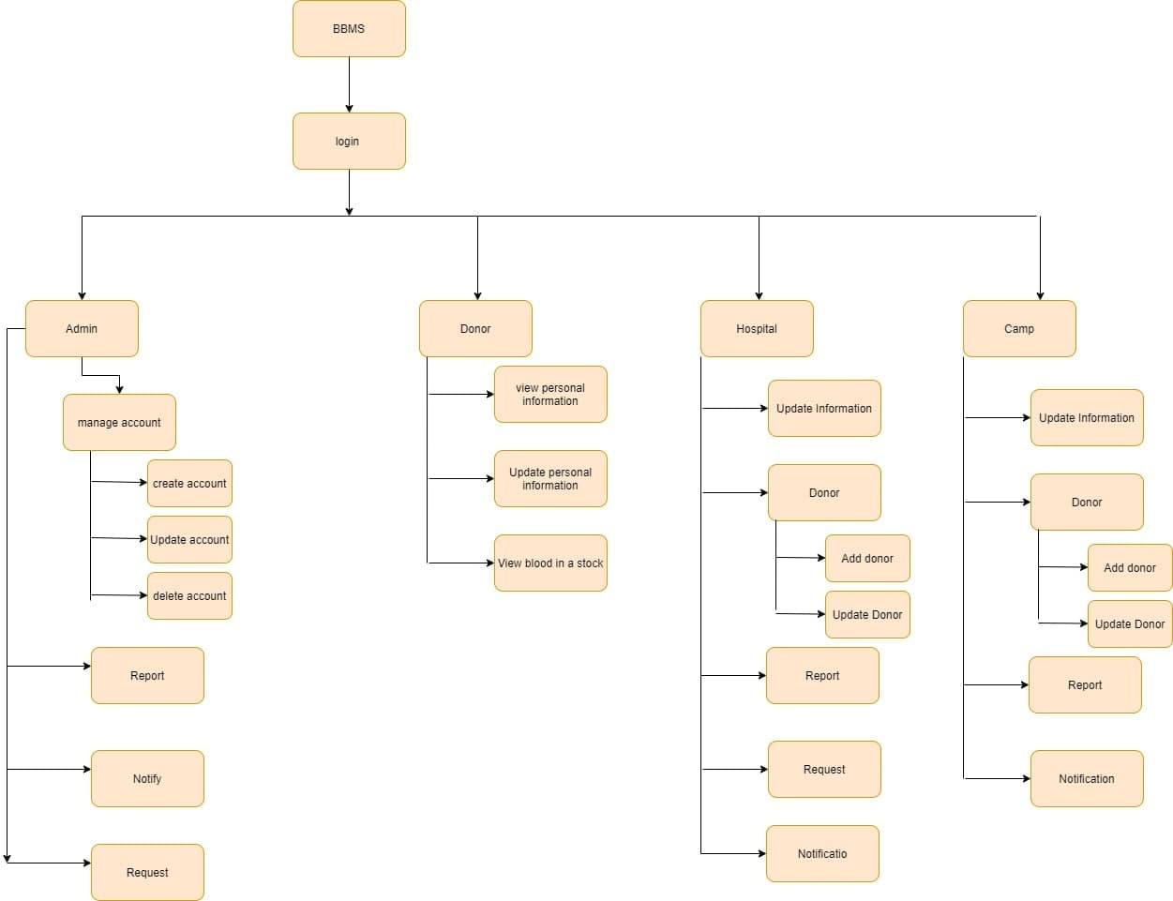

Figure 53. User interface design